**The Nexus of Climate Change, Migration and Conflict in Sudan**

Sarah Wahby

May 2025

# **Introduction**

The Sahel region in Africa is particularly vulnerable to climate change (NUPI & SIPRI, 2021). It experiences a high recurrence of extreme events such as droughts and flooding along with a faster rise in temperatures than the global average. This vulnerability is exacerbated by the widespread reliance of the population on natural resources dependent livelihoods. Beyond its direct impacts on health, livelihoods and access to resources, climate change also affects security through the increased incidence of conflict (M. Burke et al., 2015; Harari & Ferrara, 2018; Hsiang et al., 2013). The mechanisms underpinning the relationship between climate change and conflict are however less clear.

Migration is hypothesized as a strong potential mechanism that mediates this relationship. On one hand, long term mass migration to areas with more abundant resources or to cities puts more pressure on limited resources. This could create tensions between migrants and host communities especially in case of higher ethnic diversity (Koubi, 2019). On the other hand, more specific to the Sahel context and similar contexts which embrace farmers and pastoralists in neighboring areas, changing patterns of seasonal migration of pastoralists could be the culprit. In short, water and pasture shortage due to lower rainfall pushes pastoralists to graze on sedentary farmers’ land before the harvest thus destroying crops, disrupting long-standing symbiotic relationships that existed between the two groups and fueling conflicts (Cabot, 2017; McGuirk & Nunn, 2025). Some have argued that recent conflicts such as the Syrian civil war in 2011 and the Darfur conflict in 2003 are empirical examples of the realization of the first and second migration channels respectively (De Juan, 2015; Kelley et al., 2015). Others have refuted the existence of a relationship between these conflicts and climatic conditions altogether (Kevane & Gray, 2008; Selby et al., 2017)

I study the interplay of climate change, internal migration and conflict in Sudan, a country in the Sahel bearing the brunt of climate change. Specifically, I investigate the effect of recurring droughts, one of the main manifestations of climate change in Sudan, on conflict incidence. I examine the incidence of conflict both in origin localities[1]: those directly affected by drought and in destination localities: those connected to them through migration routes.

I use data on rainfall and temperature from the CHIRPS and CHIRTS databases[2] respectively, to create a drought index, the Standardized Precipitation and Evapotranspiration Index (SPEI), suitable for the Sudanese context. I use conflict data from the Uppsala Conflict Data Program (UCDP). This database records incidents of conflict “where armed force was used by an organized actor against another organized actor, or against civilians, resulting in at least 1 direct death” and if the conflict reaches at least 25 battle-related deaths in the year (Sundberg & Melander, 2013). To define migration routes I use data from the Sudan Labor Market Panel Survey 2022 (Krafft et al., 2024) which documents all six months or longer migration experiences of a national sample of the Sudanese population. I define a migration route as a route between two localities that witnessed migrations at the 90th percentile or above the frequency of migration among all migration incidents detected in my sample. I complement this data with ethnographic documentation of seasonal migration patterns of pastoralists by the Feinstein International Center at Tufts University (Behnke et al., 2020; Krätli et al., 2013; Sulieman & Ahmed, 2017; Sulieman & Young, 2023; Young et al., 2013, 2016). I use the SPEI index to define a binary drought variable and conduct a difference in differences between localities experiencing drought to those not experiencing drought before and after the fact.

Preliminary results show a negative relationship between severe droughts and conflict incidence in the origin locality but a positive relationship with conflict incidence in the destination locality. This suggests that conflict occurs in regions with higher supply of water and those connected with a region experiencing drought by a migration route. This supports a scenario where individuals migrate to areas with more abundant resources creating more competition over resources that incites conflict.

This paper contributes directly to the literature on climate change and conflict which overwhelmingly supports a positive relationship between climate shocks and conflict (M. Burke et al., 2015; Hsiang et al., 2013). Evidence specific to the African continent documents a positive relationship between warming and civil conflict (M. B. Burke et al., 2009, 2010) and droughts and civil conflict (Harari & Ferrara, 2018). Some researchers suggested that both increases and decreases in rainfall can be associated with higher conflict incidence both in the broader African context (Hendrix & Salehyan, 2012) and specifically in East Africa (Ralston, 2013). Others have argued that the link between climate shocks and conflict is rather weak (Buhaug, 2010; Couttenier & Soubeyran, 2014).

This paper also contributes to the empirical literature on the role of climate change in civil conflicts in Sudan. Evidence suggests that conflict in Sudan is driven by higher temperatures which disproportionately affect pastoralist areas making these communities more vulnerable to conflict (Maystadt et al., 2015). Moreover, evidence on the early phase of the Darfur civil conflict point to higher incidence of conflict in areas with more abundant water and vegetation corroborating a story of migration and competition over resources (De Juan, 2015).

Finally, it contributes to the small nascent literature on migration as a mediator of the relationship between climate change and conflict. Evidence from the African continent supports a relationship between pastoralists’ seasonal migration and conflict with ethnically different neighboring communities (McGuirk & Nunn, 2025). Moreover, cross country migration was found to be linked with lower conflict incidence in origin countries and to have no effect on conflict in destination countries (Bosetti et al., 2018).

# **Data and Measurement**

## **Drought**

Drought is one of the main manifestations of climate change in Sudan. In the past 60 years the country has experienced a higher recurrence of droughts taking its toll on agricultural communities. Droughts are nonetheless complex phenomena with no universal definition (Mishra & Singh, 2010). While it is broadly understood to be the reduction of precipitation compared to the norm over an extended period, the specificities are more nuanced and local context matters (Dorelien and Grace, 2023). A shortened or delayed rainy season, while inconsequential in contexts with perennial irrigation, may result in reduced yields in arid settings with rainfed agriculture even if the total seasonal precipitation is not significantly different from the long-term norm.

In addition to their complex nature, appropriate measurement methods and data collection of droughts are also crucial to detecting droughts’ onset and intensity. Out of a long list of indices used to calculate droughts[3], the Standardized Precipitation Index (SPI) and its upgraded version the Standardized Precipitation and Evapotranspiration Index (SPEI) fare better than most in the context of this study. The flexibility to calculate these indices at different time scales allows for measuring short-term water supplies, an indicator for soil moisture and soil wetness, essential for detecting agricultural droughts and consequent crop failure (Mishra & Singh, 2010). Since agricultural production is the main mechanism through which droughts are expected to affect individuals livelihoods and availability of resources opting for a suitable measure for agricultural droughts is a sensible choice. In addition, both indices are easy to calculate, especially SPI given that it only relies on precipitation data. The SPEI, taking the extra step of accounting for evapotranspiration, offers a more complete representation of climatic water balance, making it particularly useful for analyzing drought impacts across both rainfed and irrigated agricultural systems (Vicente-Serrano et al., 2010). These indices are also spatially stable (Mishra & Singh, 2010) allowing for comparison across different agroecological zones pertinent to the Sudanese context. Most importantly when compared to other indices (not including SPEI), SPI was superior in detecting drought events in East Africa given its aforementioned strengths in addition to its adaptability to the local climate and modest data requirements particularly important in a region with limited weather stations (Ntale & Gan, 2003).

The SPEI index is a standardized measure that takes values from -2 to 2 as explained in table 1

Table 1 Significance of values of SPEI index

|  |  |
| --- | --- |
| Values | Drought category |
| 0 to -0.99 | Mild Drought |
| -1 to -1.49 | Moderate Drought |
| -1.5 to -1.99 | Severe Drought |
| ≤-2 | Extreme Drought |

Source: (McKee et al., 1993)

While Vicente-Serrano et al., 2010 have done the work of creating a full database of SPEI, I follow Harari & Ferrara's (2018) approach in recalculating the index using different data sources for temperature and precipitation. The CRU TS3.0 that Vicente-Serrano et al. (2010) use to calculate the SPEI calculation rely on observations recorded by weather stations which present certain limitations in the context of Sudan and sub-Saharan Africa more generally. First, due to the sparse distribution of weather stations, substantial interpolation is required to generate data at the level of analysis required (Harari & Ferrara, 2018). This heavy interpolation could artificially induce spatial correlation in weather shocks, potentially biasing estimates of true interdependencies. Second, the presence and availability of weather stations data may itself be endogenous to conflict dynamics. I, therefore, use precipitation and temperature data produced by the Climate Hazards Center at the University of California Santa Barbra: CHIRPS and CHIRTSMax respectively. These datasets are superior to CRU TS3.0 because they combine both satellite and station data overcoming biases typical to the usage of only one or the other of these two sources of data (Climate Hazards Center, UC Santa Barbra). Both CHIRPS and CHIRTS data are available daily in a 5 KM by 5 KM grid.

In my analysis, I average the daily data to a month and the grided data to the locality level to calculate the SPEI at a month locality level for the years 1983 to 2016. Given that short-term scales are more suitable for detecting agricultural conditions, I calculate SPEI at a 4-month scale (Harari & Ferrara, 2018). I use both the raw values of the SPEI index and a drought measure that takes 0 or 1 if SPEI is less than or equal to -1.5, that is if this period experienced anything from a severe to an extreme drought.

## **Conflict**

There are two main sources of geolocated conflict data. The Uppsala Conflict Data Program (UCDP) and Armed Conflict Location and Event Data (ACLED). Each dataset has its strengths. The UCDP provides records of conflict events going back to 1989 and therefore allows to form a longer-term dataset than the ACLED data available providing records starting 1997. ACLED data, however, provides a more comprehensive documentation of conflict events including a wide range of civil unrest events such as rebels and riots using a variety of sources. The UCDP only records conflicts of at least 25 battle-related deaths per year. I rely on the UCDP data given its longer time span. I believe the conflict documentation approach of the UCDP data is suitable for the context of Sudan where large civil conflicts with considerable battle deaths are ubiquitous. From the UCDP data I construct two variables, a binary variable for a conflict happening or not and a fatalities variable indicating the number of fatalities in each conflict. In future versions, I will use the ACLED database as a robustness check.

## **Migration routes**

To define migration routes, I use retrospective migration data at the individual level from the Sudan Labor Market Panel Survey (SLMPS) 2022 (OAMDI, 2023). The survey tracks the history of movement of the individuals interviewed throughout their life from one locality[4] in Sudan to another or outside the country that lasted more than 6 months. It has information on the year of movement, origin locality, destination locality and reason of movement. To identify migration routes, I count the number of movements between two localities in the SLMPS dataset across all individuals and all years. I consider two localities having an established migration route between them if there are at least four or six movements between them. A sum of four or six movements between two localities correspond to the 85th percentile and 90th percentile of the number of movements between localities in the dataset respectively (Figure 1). In a future iteration of the paper I aim to support my migration data with ethnographic evidence on pastoralist migration routes.

Figure 1 Distribution of frequency of movements between pairs of localities

## **Descriptive statistics**

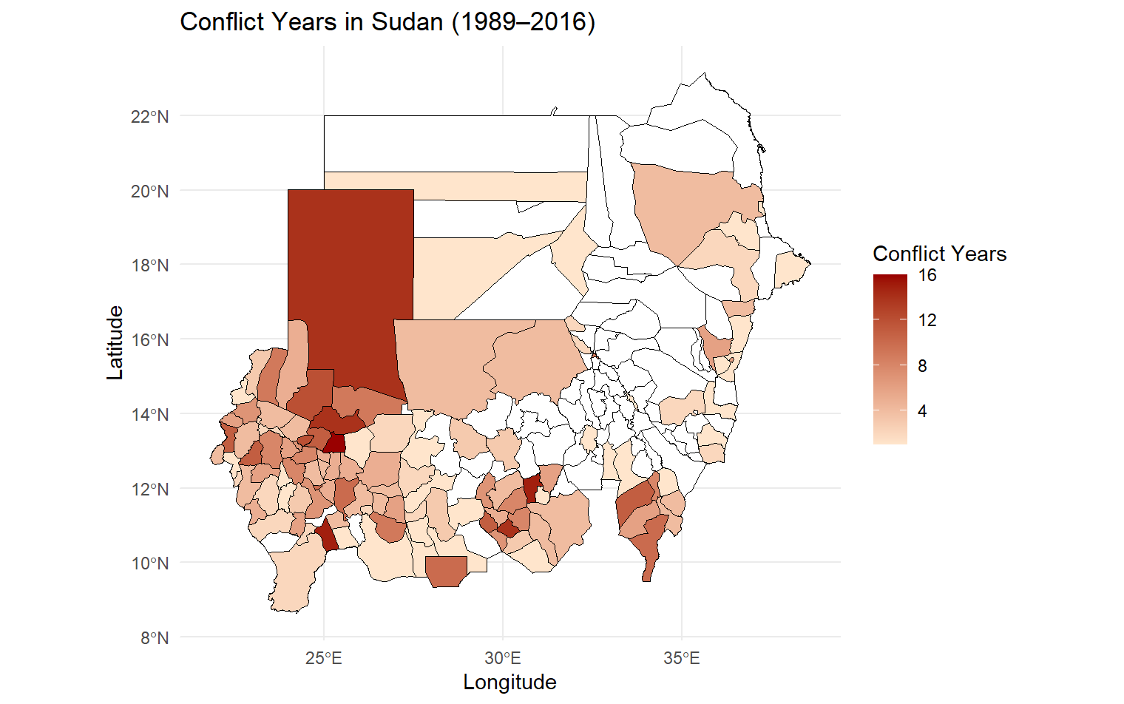

Figure 2 Conflict years (1989-2016) (UCDP data)

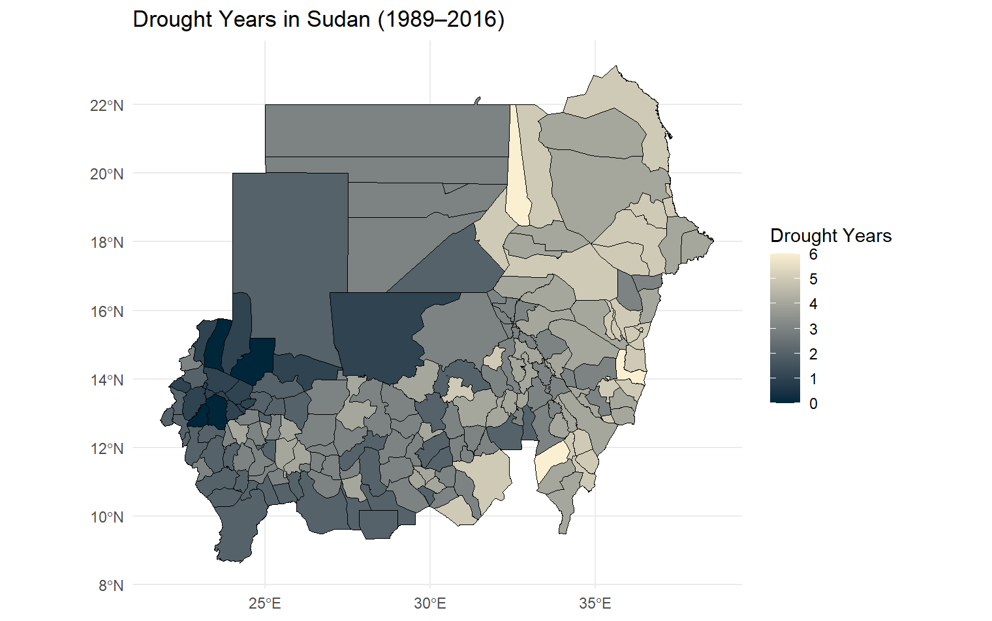

Figure 3 Drought years (1989-2016) (based on SPEI calculated using CHIRPS and CHIRTS data)

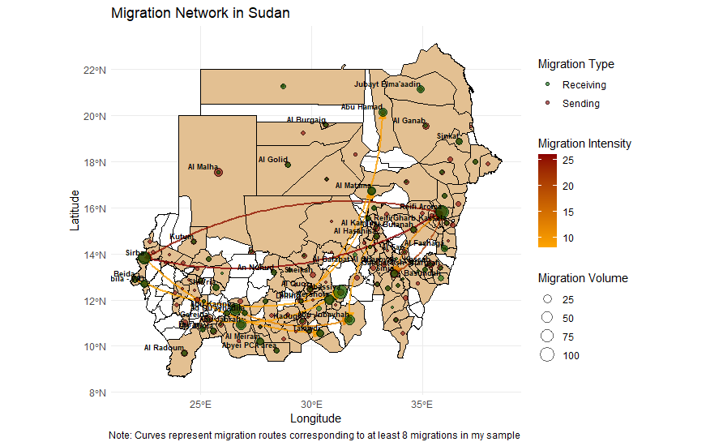

Figure 4 Migration network in Sudan (SLMPS data)

# **Empirical Strategy**

To estimate the effect of droughts on conflict whether in the origin or the destination location I estimate a series of Two-Way Fixed Effects models using different definitions of the treatment variable.

First, I define the treatment as the continuous value of the SPEI index. Higher values of the index indicate more water supplies and lower values indicate less water supplies, a negative value of the coefficient on SPEI indicates a positive correlation between drought and conflict. I also estimate lagged models accounting for the lagged effect of droughts up to two lags. I define destination locality as locality with an established migration route (4 or 6 movements in the dataset) with the origin locality.

Equations 1 to 3 correspond to the relationship between SPEI in the present and lagged SPEI on conflict in the origin locality. Equations 4 to 6 correspond to the relationship between SPEI and conflict in the destination location. The main difference aside from the outcome variable is that in equations 4 to 6 I take the fixed effects of the migration route and year instead of locality of origin and year (in equations 1-3).

$C_{o,t=}{β+β}_{0}{SPEI}_{o,t}+α_{o}+γ_{t}{+ε}_{ot}$ (1)

$C_{o,t=}{β+β}_{0}{SPEI}_{o,t}+β_{1}{SPEI}_{o,t-1}+α_{o}+γ_{t}{+ε}_{ot}$ (2)

$C_{o,t=}{β+β}_{0}{SPEI}_{o,t}+β_{1}{SPEI}_{o, t-1}+β_{2}{SPEI}_{o,t-2 }+α_{o}+γ_{t}{+ε}_{ot}$ (3)

$C_{o,t}$: Conflict in the origin locality (locality where drought occurred) in year t

${SPEI}_{o,t}$: Value of SPEI index in the locality of origin at time t

${SPEI}_{d,t}$: Value of SPEI index in the locality of destination at time t

${SPEI}_{o,t-i}$: Lagged value of SPEI index in the locality of origin, i =(1, 2)

$α_{l}$: locality of origin fixed effect

$ε_{o,t}$: error term accounting for other unobservable characteristics for locality of origin and year

$C_{d,t=}{β+β}_{0}{SPEI}_{o,t}+α_{o}+φ_{r}+γ_{t}{+ε}_{rt}$ (4)

$C_{d,t=}{β+β}_{0}{SPEI}_{o, t}+β_{1}{SPEI}_{o,t-1}+α_{o}+φ_{r}+γ_{t}{+ε}_{rt}$ (5)

$C_{d,t=}{β+β}_{0}{SPEI}_{o,t}+β_{1}{SPEI}_{o, t-1}+β_{2}{SPEI}_{o,t-2}+α_{o}+φ_{r}+γ_{t}{+ε}_{rt}$ (6)

$C_{d}$: Conflict in the destination locality (locality with established migration route with a locality that experienced drought)

${SPEI}_{d,t}$: Value of SPEI index in the locality of destination at time t

${SPEI}_{d,t-i}$: Lagged value of SPEI index in the locality of destination, i takes the value 1 or 2

$φ_{r}$: migration route fixed effect

$ε_{rt}$: error term accounting for other unobservable characteristics for migration route and year

In my second specification I define treatment as a binary variable that takes 1 if origine locality experienced severe drought, 0 otherwise. I also use different specifications of this model taking into account present drought events, drought events in the past year, and drought events in the past two years. This is not a traditional event study given that the treatment turns on and off. In a future iteration of this paper I plan to address this issue.

$C_{o,t=}{β+β}_{0}{SevereDrought}_{o,t}+α_{o}+γ_{t}{+ε}_{ot}$ (7)

$C_{o,t=}{β+β}_{0}{SevereDrought}_{o,t-1}+α_{o}+γ_{t}{+ε}_{ot}$ (8)

$C_{o,t=}{β+β}_{0}{SevereDrought}_{o,t-2}+α_{o}+γ_{t}{+ε}_{ot}$ (9)

${SevereDrought}_{o,t}$: Origin locality experienced an SPEI less than or equal to -1.5 in time t

${SevereDrought}_{o,t-i}$: Origin locality experienced an SPEI less than or equal to -1.5 in time t-i, i=(1,2)

$C_{d,t=}{β+β}_{0}{SevereDrought}_{o,t}+α_{o}+φ_{r}+γ_{t}{+ε}_{rt}$ (10)

$C_{d,t=}{β+β}_{0}{SevereDrought}_{o,t-1}+α_{o}+φ_{r}+γ_{t}{+ε}_{rt}$ (11)

$C_{d,t=}{β+β}_{0}{SevereDrought}_{o,t-2}+α_{o}+φ_{r}+γ_{t}{+ε}_{rt}$ (12)

# **Results**

The results indicate the existence of a positive and significant relationship between the SPEI values and the incidence of conflict in origin location suggesting that droughts decrease the probability of conflict at least in the origin location. While the relationship between the SPEI and the conflict in destination location is not significant, the sign holds when I limit destination locations to the five movement migration route definition. The results are clearer when I use the incidence of a severe drought as a treatment variable. I find that a drought in the past year is significantly predictive of a conflict at present in the origin location. Conversely, a severe drought is a significant predictor of conflict in the destination location up to two years from the occurrence of drought.

Table 2: Relationship between SPEI and conflict incidence in origin location

|  |  |  |  |  |  |  |
| --- | --- | --- | --- | --- | --- | --- |
|  | Conflict in origin | | Conflict in origin | | Conflict in origin | |
| SPEI | 0.055 | *** | 0.042 | *** | 0.044 | *** |
|  | (0.010) |  | (0.010) |  | (0.010) |  |
| SPEI (t-1) |  |  | 0.054 | *** | 0.050 | *** |
|  |  |  | (0.009) |  | (0.009) |  |
| SPEI (t-2) |  |  |  |  | 0.018 | ** |
|  |  |  |  |  | (0.009) |  |
| Constant | 0.090 |  | 0.092 |  | 0.093 |  |
|  | {0.002} |  | {0.006} |  | {0.034} |  |
| N | 6426 |  | 6237 |  | 6048 |  |

Table 3: Relationship between SPEI and conflict incidence in destination location (migration routes defined based on four movements between localities)

|  |  |  |  |  |  |  |
| --- | --- | --- | --- | --- | --- | --- |
|  | Conflict in destination locality | | Conflict in destination locality | | Conflict in destination locality | |
| SPEI | -0.047 | * | -0.038 | * | -0.045 | * |
|  | (0.024) |  | (0.021) |  | (0.024) |  |
| SPEI (t-1) |  |  | -0.029 |  | -0.040 |  |
|  |  |  | (0.030) |  | (0.027) |  |
| SPEI (t-2) |  |  |  |  | 0.033 |  |
|  |  |  |  |  | (0.029) |  |
| Constant | 0.113 |  | 0.115 |  | 0.117 |  |
|  | {0.006} |  | {0.012} |  | {0.023} |  |
| N | 655 |  | 647 |  | 635 |  |
|  |  |  |  |  |  |  |

Table 4: Relationship between SPEI and conflict incidence in destination location (migration routes defined based on six movements between localities)

|  |  |  |  |  |  |  |
| --- | --- | --- | --- | --- | --- | --- |
|  | Conflict in destination locality | | Conflict in destination locality | | Conflict in destination locality | |
|  |  |  |  |  |  |  |
| SPEI | -0.157 | *** | -0.145 | *** | -0.145 | *** |
|  | (0.036) |  | (0.033) |  | (0.033) |  |
| SPEI (t-1) |  |  | -0.104 |  | -0.108 |  |
|  |  |  | (0.081) |  | (0.078) |  |
| SPEI (t-2) |  |  |  |  | 0.028 |  |
|  |  |  |  |  | (0.083) |  |
| Constant | 0.134 |  | 0.136 |  | 0.142 |  |
|  | {0.004} |  | {0.004} |  | {0.018} |  |
| N | 346 |  | 341 |  | 334 |  |

Table 5: Relationship between severe drought incidence and conflict incidence in origin location

|  |  |  |  |  |  |  |
| --- | --- | --- | --- | --- | --- | --- |
|  | Conflict in origin locality | | Conflict in origin locality | | Conflict in origin locality | |
| Severe Drought | -0.004 |  |  |  |  |  |
|  | (0.048) |  |  |  |  |  |
| Severe Drought (t-1) |  |  | -0.108 | *** |  |  |
|  |  |  | (0.037) |  |  |  |
| Severe Drought (t-2) |  |  |  |  | 0.091 |  |
|  |  |  |  |  | (0.082) |  |
| Constant | 0.090 |  | 0.090 |  | 0.090 |  |
|  | {0.010} |  | {0.007} |  | {0.016} |  |
| N | 6426 |  | 6426 |  | 6426 |  |

Table 6: Relationship between severe drought incidence and conflict incidence in destination location (migration routes defined based on four movements between localities)

|  |  |  |  |  |  |  |
| --- | --- | --- | --- | --- | --- | --- |
|  | Conflict in destination locality | | Conflict in destination locality | | Conflict in destination locality | |
|  |  |  |  |  |  |  |
| Severe Drought | -0.001 |  |  |  |  |  |
|  | (0.095) |  |  |  |  |  |
| Severe Drought (t-1) |  |  | -0.058 |  |  |  |
|  |  |  | (0.093) |  |  |  |
| Severe Drought (t-2) |  |  |  |  | 0.202 |  |
|  |  |  |  |  | (0.172) |  |
| Constant | 0.003 |  | 0.003 |  | 0.004 |  |
|  | {0.001} |  | {0.001} |  | {0.001} |  |
| N | 655 |  | 655 |  | 655 |  |

Table 7 Relationship between severe drought incidence and conflict incidence in destination location (migration routes defined based on six movements between localities)

|  |  |  |  |  |  |  |  |
| --- | --- | --- | --- | --- | --- | --- | --- |
|  | Conflict in destination locality | | Conflict in destination locality | | Conflict in destination locality | | |
|  |  |  |  |  |  | |  |
| Severe Drought | 0.163 | *** |  |  |  | |  | |
|  | (0.044) |  |  |  |  | |  | |
| Severe Drought (t-1) |  |  | 0.110 |  |  | |  | |
|  |  |  | (0.098) |  |  | |  | |
| Severe Drought (t-2) |  |  |  |  | 0.044 | |  | |
|  |  |  |  |  | (0.103) | |  | |
| Constant | 0.132 |  | 0.132 |  | 0.133 | |  | |
|  | {0.005} |  | {0.011} |  | {0.011} | |  | |
| N | 346 |  | 346 |  | | 346 |  | |

# **References**

Behnke, R., Young, H., Sulieman, H. M., Robinson, S., & Idris, A. E. (2020). The seasonal imperative: Environmental drivers of livestock mobility in East Darfur, Sudan. *Land Use Policy*, *99*, 105014. https://doi.org/10.1016/j.landusepol.2020.105014

Bosetti, V., Cattaneo, C., & Peri, G. (2018). *Should they stay or should they go? Climate Migrants and Local Conflicts* (Working Paper 24447). National Bureau of Economic Research. https://doi.org/10.3386/w24447

Buhaug, H. (2010). Climate not to blame for African civil wars. *Proceedings of the National Academy of Sciences*, *107*(38), 16477–16482. https://doi.org/10.1073/pnas.1005739107

Burke, M. B., Miguel, E., Satyanath, S., Dykema, J. A., & Lobell, D. B. (2009). Warming increases the risk of civil war in Africa. *Proceedings of the National Academy of Sciences*, *106*(49), 20670–20674. https://doi.org/10.1073/pnas.0907998106

Burke, M. B., Miguel, E., Satyanath, S., Dykema, J. A., & Lobell, D. B. (2010). Climate robustly linked to African civil war. *Proceedings of the National Academy of Sciences*, *107*(51). https://doi.org/10.1073/pnas.1014879107

Burke, M., Hsiang, S. M., & Miguel, E. (2015). Climate and Conflict. *Annual Review of Economics*, *7*(1), 577–617. https://doi.org/10.1146/annurev-economics-080614-115430

Cabot, C. (2017). *Climate Change, Security Risks and Conflict Reduction in Africa* (Vol. 12). Springer Berlin Heidelberg. https://doi.org/10.1007/978-3-642-29237-8

Couttenier, M., & Soubeyran, R. (2014). Drought and Civil War in Sub‐Saharan Africa. *The Economic Journal*, *124*(575), 201–244. https://doi.org/10.1111/ecoj.12042

De Juan, A. (2015). Long-term environmental change and geographical patterns of violence in Darfur, 2003–2005. *Political Geography*, *45*, 22–33. https://doi.org/10.1016/j.polgeo.2014.09.001

Harari, M., & Ferrara, E. L. (2018). Conflict, Climate, and Cells: A Disaggregated Analysis. *The Review of Economics and Statistics*, *100*(4), 594–608. https://doi.org/10.1162/rest_a_00730

Hsiang, S. M., Burke, M., & Miguel, E. (2013). Quantifying the Influence of Climate on Human Conflict. *Science*, *341*(6151), 1235367. https://doi.org/10.1126/science.1235367

Kelley, C. P., Mohtadi, S., Cane, M. A., Seager, R., & Kushnir, Y. (2015). Climate change in the Fertile Crescent and implications of the recent Syrian drought. *Proceedings of the National Academy of Sciences*, *112*(11), 3241–3246. https://doi.org/10.1073/pnas.1421533112

Kevane, M., & Gray, L. (2008). Darfur: Rainfall and conflict. *Environmental Research Letters*, *3*(3), 034006. https://doi.org/10.1088/1748-9326/3/3/034006

Koubi, V. (2019). *Climate Change and Conflict*.

Krafft, C., Assaad, R., & Cheung, R. (2024). Introducing the Sudan Labor Market Panel Survey 2022. *Demographic Research*, *51*, 81–106. https://doi.org/10.4054/DemRes.2024.51.4

Krätli, S., El Dirani, O. H., & Young, H. (2013). *Standing Wealth: Pastoralist Livestock Production and Local Livelihoods in Sudan*. United Nations Environment Programme. http://fic.tufts.edu/publication-item/standing-wealth/

Maystadt, J.-F., Calderone, M., & You, L. (2015). Local warming and violent conflict in North and South Sudan. *Journal of Economic Geography*, *15*(3), 649–671. https://doi.org/10.1093/jeg/lbu033

McGuirk, E. F., & Nunn, N. (2025). Transhumant Pastoralism, Climate Change, and Conflict in Africa. *Review of Economic Studies*, *92*(1), 404–441. https://doi.org/10.1093/restud/rdae027

McKee, T. B., Doesken, N. J., & Kleist, J. (1993). *THE RELATIONSHIP OF DROUGHT FREQUENCY AND DURATION TO TIME SCALES*.

Mishra, A. K., & Singh, V. P. (2010). A review of drought concepts. *Journal of Hydrology*, *391*(1–2), 202–216. https://doi.org/10.1016/j.jhydrol.2010.07.012

Ntale, H. K., & Gan, T. Y. (2003). Drought indices and their application to East Africa. *International Journal of Climatology*, *23*(11), 1335–1357. https://doi.org/10.1002/joc.931

NUPI, & SIPRI. (2021). *Climate, Peace and Security Fact Sheet Sahel*.

OAMDI. (2023). *Labor Market Panel Surveys (LMPS)- SLMPS 2022- Central Bureau of Statistics, Sudan (CBS)* (Version Version 2.2 of Licensed Data Files) [Dataset]. Economic Research Forum (ERF. http://erf.org.eg/data-portal/

Selby, J., Dahi, O. S., Fröhlich, C., & Hulme, M. (2017). Climate change and the Syrian civil war revisited. *Political Geography*, *60*, 232–244. https://doi.org/10.1016/j.polgeo.2017.05.007

Sulieman, H. M., & Ahmed, A. G. M. (2017). Mapping the pastoral migratory patterns under land appropriation in East Sudan: The case of the Lahaween Ethnic Group. *The Geographical Journal*, *183*(4), 386–399. https://doi.org/10.1111/geoj.12175

Sulieman, H. M., & Young, H. (2023). The Resilience and Adaptation of Pastoralist Livestock Mobility in a Protracted Conflict Setting: West Darfur, Sudan. *Nomadic Peoples*, *27*(1), 3–31. https://doi.org/10.3197/np.2023.270102

Sundberg, R., & Melander, E. (2013). Introducing the UCDP Georeferenced Event Dataset. *Journal of Peace Research*, *50*(4), 523–532. https://doi.org/10.1177/0022343313484347

Vicente-Serrano, S. M., Beguería, S., López-Moreno, J. I., Angulo, M., & El Kenawy, A. (2010). A New Global 0.5° Gridded Dataset (1901–2006) of a Multiscalar Drought Index: Comparison with Current Drought Index Datasets Based on the Palmer Drought Severity Index. *Journal of Hydrometeorology*, *11*(4), 1033–1043. https://doi.org/10.1175/2010JHM1224.1

Young, H., Behnke, R., Sulieman, H., Robinson, S., & Mohamed, A. (2016). *Risk, Resilience, and Pastoralist Mobility*. Feinstein International Center.

Young, H., Sulieman, H., Behnke, R., & Cormack, Z. (2013). *Pastoralism in Practice: Monitoring Livestock Mobility in Contemporary Sudan*. United Nations Environment Programme. http://fic.tufts.edu/publication-item/pastoralism-in-practice/

1. Second administrative level in Sudan
2. The CHIRPS and CHIRPS databases are produced by the Climate Hazards Center at the University of California Santa Barbra
3. See Mishra and Singh 2010 for a review of the different drought indices.
4. Second administrative level in Sudan. There are 189 localities in Sudan but 124 in my dataset.