The Impact of Child Labour on Educational Outcomes in Lesotho: A Non-Parametric Bounds Approach∗

’Mafalatsi Rosalea Souru† Ramaele Moshoeshoe‡

**Abstract**

This paper investigates the impact of child labour on educational outcomes in Lesotho. Numerous studies have examined this issue. Amongst them, few have specifically addressed how child labour affects educational outcomes in the case of Lesotho. We advance the literature using the Lesotho 2018 Multiple Indicator Cluster Survey and the non-parametric bounds approach. This relies on weak assumptions. The decision to choose between schooling and work is made concurrently and may be influenced by the same, possibly unobserved variables. Hence, determining the causal effect of child labour on education may be challenging. We, therefore, address the endogeneity problem using the assumption of a monotone instrumental variable. We use the mother’s highest level of education attained as an instrument. It is directly and positively correlated with educational outcomes. The findings of this study show the inconclusive impact of child labour on all educational outcomes. For boys, the results are inconclusive for all the outcomes, with both positive and negative estimated impacts. In contrast, for girls, the results are inconclusive for all the outcomes except for foundational Sesotho reading skills, where there is a positive impact, even though the range is too wide to be informative. Moreover, the results show that, on average, child labour’s association with education outcomes are concentrated amongst the boys.

JEL-Classification: J22; I21; C14; O55.

Keywords: Child Labour; Education; Foundational Skills; Lesotho

∗Acknowledgements

†National University of Lesotho. Email: [rosaleasouru1@gmail.com](mailto:email@gmail.com).

‡Global Education Analytics Institute (GEAI) & Partnership for Economic Policy (PEP). Email: [ramaele.moshoeshoe@pep-net.org; rmoshoeshoe@gmail.com](mailto:email@gmail.com).

# — Introduction

Sub-Saharan Africa (SSA) has the lowest level of human capital, with over 90% of children lacking foundational skills (Gust et al., 2024). The region also has the highest prevalence (24%) of child labour and the largest number of children in child labour (ILO & UNICEF, 2021). Child labour is believed to displace school attendance and learning, and thus inhibits human capital accumulation (Baland & Robinson, 2000; Keane et al., 2022) with negative implications for economic development (Gust et al., 2024). Therefore, there is an international commitment to eliminate all the forms of child labour by 2025 (see Sustainable Development Goal (SDG) 8.7). However, empirical evidence on the effects of child labour on educational outcomes is mixed and appears to be context-specific. Conversely, most studies find that child labour has negative effects on school enrolment and academic achievement (Gunnarsson et al., 2006; Beegle et al., 2009; Zabaleta, 2011; Haile & Haile, 2012; He, 2016; Emerson et al., 2017; Delprato & Akyeampong, 2019; Mussa et al., 2019; Kassouf et al., 2020; Lee et al., 2021; Keane et al., 2022). There are, however, some small differences within this literature, which might be consequential in certain contexts. For example, Keane et al. (2022) and Kassouf et al. (2020) show that time spent in child work, either market/farm or household chores, is detrimental to a child’s cognitive development, but, in the case of Keane et al. (2022), only if it displaces school/study time. Zabaleta (2011), on the other hand, shows that the time a child spends in market work has larger negative effects on educational outcomes than time spent on household

chores.

There is also some evidence that child labour has no effect or even a positive effect on educational outcomes. Dumas (2012) finds that, in Senegal, child work does not harm cognitive achievement, but it increases oral mathematics. Further, Kana et al. (2010) finds no trade-off between child work and educational attainment. However, Phoumin (2008) and Zabaleta (2011) discover that the impact of child work on education depends on the intensity of child work: below a certain threshold (say three hours in Nicaragua) does not affect education. These results are consistent with the theoretical predictions of Fan (2004) that a small increase in child labour may not harm a child’s cognitive development.

These conflicting results could be explained by several factors, including the country’s institutional context, the sample age limit (7-14 years old versus 14-18 years old), the type of child work considered, the definition of child labour, and the identification strategies, amongst

others. For instance, He (2016) conducted a study in China where compulsory education comprises primary and junior secondary education. On the one hand, the average of completed years of schooling for children aged 5 to 17 years is 8 years; the minimum working age is 16 years; and the children mostly work in factories. He has discovered that child labour has a detrimental impact on academic success. On the other hand, Kana et al. (2010) conducted their study in Cambodia, where the minimum working age is 14 years, and the children are engaged in agricultural activities, garments and textiles. They have found no evidence of a trade-off between child labour and educational attainment as the children work within critical threshold levels (that is, they work below a minimum number of hours per week).

Again, there are differences in how these studies measure child labour. For instance, most studies use the time spent (hours or years) doing economic activities and/or household chores to measure child labour (Zabaleta, 2011; Dumas, 2012; Emerson et al., 2017; Lee et al., 2021; Keane et al., 2022). At the same time, Kassouf et al. (2020) use indicators for household chores or market work. It does not distinguish between child work and child labour. Therefore, this literature does not distinguish child work from child labour; it looks at the effects of child hours of work on educational outcomes.1 Not all the child work is bad for the child development and later human capital accumulation. Thus, policies based on these results, such as proposing a total ban on all the forms of child work (Keane et al., 2022), may not be helpful in low-income countries where child work is prevalent and is considered part of a positive upbringing. Such policies make it hard to develop the policies that would limit the harmful effects of child labour while promoting the potentially positive effects of child work, including the promotion of cognitive and socio-emotional skills, to mention but a few.

Further, most prior literature uses parametric methods, relying on matching and instrumental variable (IV) identification strategies with strong assumptions (Dumas et al., 2008; Zabaleta, 2011; Delprato & Akyeampong, 2019; Lee et al., 2021; Boutin & Jouvin, 2022). Therefore, the estimates are likely biased (Boutin & Jouvin, 2022). For instance, Lee et al. (2021) uses annual tuition fees across schools as an IV, which does likely not satisfy the orthogonality condition as high tuition fees may directly or indirectly affect academic achievement than through child labour.

1. According to the International Labour Organisation (ILO), child labour referees to “work that is mentally, physically, socially or morally dangerous and harmful to children; and/or interferes with their schooling”, while child work is participation or hours worked in the household chores and/or economic activities that are considered unharmful and socio-economically beneficial to the child, contributing to their education in a broader way to their development. (see [https://www.ilo.org/topics/child-labour/what-child-labour).](http://www.ilo.org/topics/child-labour/what-child-labour))

This paper, therefore, investigates the impact of child labour on educational outcomes in Lesotho. We use the 2018 Lesotho Multiple Indicator Cluster Survey (MICS) and employ the nonparametric bounds approach by Manski (1989, 1990, 1995), which applies mild and relatively plausible assumptions to overcome the selection issues.

Our results show that the impact of child labour is inconsistent across the various measures of educational outcomes. We find that the effects of the time spent doing market work and household chores on the completed years of schooling, foundational English reading, foundational Sesotho reading and numeracy skills are inconclusive. Since there are indications of potential negative effects shown by the slightly negative estimates of average treatment effect (ATE), wide and overlapping bounds from the different assumptions faced reflect a great amount of uncertainty, including both positive and negative effects. This would, therefore, imply that the true impact of child labour on these educational outcomes are not definitively established. These findings are in line with the findings from Emerson & Souza (2011); and Beegle et al. (2009). These studies reflect the broader challenges in establishing a clear causal relationship between child labour and educational outcomes. They found an uncertain impact of the children’s work on learning outcomes. This can be attributed to the fact that, even though work may take away time and energy (hence having a negative impact on learning), some activities might directly or indirectly complement learning processes through the activities requiring reading, writing, or mathematical skills. Again, we find that the impact on boys is inconclusive for all the educational outcomes, suggesting a broader variety of potential impacts on schooling. At the same time, for girls, the evidence leans more consistently toward a positive influence on specific academic skills, particularly in Sesotho reading skills. These findings concur with those of the earlier studies, including Dumas (2012); Phoumin (2008); Watson (2008), which find that child labour positively affects the girls’ education more than the boys’. This is because the girls mostly do family chores, which take place under safe conditions and can be combined with schooling.

This paper contributes to the literature in several ways. First, we measure child labour following the International Labour Organisation (ILO) Convention No. 138. Therefore, we use time spent doing market work and household chores to calculate child labour, unlike the previous work that looked at the time spent doing market work (child work), excluding the time spent doing chores and did not distinguish between child work and child labour (Beegle et al., 2009; Gunnarsson et al., 2006; Dumas, 2012; Keane et al., 2022). This is essential for policy

because child participation in work and hours worked have both positive and negative effects depending on the occupation and length of exposure (De Hoop & Rosati, 2014). Second, we use objectively measured foundational skills for both in-school and out-of-school children.

Last, we employ the non-parametric bounds approach developed by Manski (1989, 1990, 1995) and widely applied in economics (see De Haan (2011, 2017) and Germinario et al. (2022)). The non-parametric bounds analysis relies on a minimal set of credible assumptions to identify an informative interval within which the actual effect falls. Therefore, the inference allows us to cater for the uncertainty in the data and provide credible policy analysis (Manski, 2011, 2019). To our knowledge, no previous study has employed this identification method to tease out the causal effects of child labour.

The rest of the paper is organised as follows: Chapter two presents the contextual background of the Lesotho educational system and child labour. Chapter three describes the data and provides descriptive analysis, followed by the methodology in Chapter four. Chapter five reports the results and discussions. Chapter six concludes this paper.

# — The Context

## Education in Lesotho

Until 2012, Lesotho had followed a 7-3-2-4 educational system, with seven years of primary school, three years of junior secondary school, two years of senior secondary school, and four years of university (Moshoeshoe et al., 2019). From 2013, Lesotho began phasing in the new integrated Curriculum and Assessment Policy (CAP), which has reorganised the education system into two levels: basic education (grades 1 to 10) and secondary education (grades 11 and 12) (Raselimo & Mahao, 2015). Children start primary school at the age of 6 or 5 if they turn 6 on or before the 30th of June in the same year. In 2000, Lesotho phased in the free primary education programme, which significantly increased enrolment (Moshoeshoe et al., 2019). Further, this country introduced compulsory primary education in 2010.

Secondary education is not free. However, the government also pays fees for a small portion of the most vulnerable orphans in secondary education, and there is a high transition rate from primary to secondary school (Moshoeshoe, 2023). There is, however, a high dropout rate within the secondary school cycle, which is potentially due to expensive school fees faced by many low-income families (Lekhetho, 2013; Moshoeshoe, 2023).

## Child Labour in Lesotho

Child labour is more prevalent in agricultural activities, mostly in herding activities, and the age requirement to work is 15 years. Understanding the effects of child labour on educational outcomes is important because the children with low educational attainment usually receive lower pay in the job market. Low earnings possibly exacerbate poverty and societal inequality. According to the International Labour Organisation (Chant & Pedwell, 2008), children are defined as anyone under 18. In Lesotho, the minimum working age is 15 years, and 15-17-year- old children must perform light work (Chant & Pedwell, 2008). However, due to inefficient enforcement of child labour laws, it is common for the children below and above the age of 15 to work in Lesotho, where child abuse and exploitation are prevalent (Metsing et al., 2020). According to UNICEF et al. (2018), 32% of 5-17-year-old children in Lesotho are in child labour, 45% of whom are from the poorest families, while 15% are from the richest families. As stated, child labour is more prevalent in agricultural activities, mostly in herding activities largely performed by boys (82% of boys and 20% of girls (UNICEF et al., 2018)). Therefore, 40% of boys

and 18% of girls are involved in child labour (UNICEF et al., 2018).

# — Data and Descriptive Analysis

## Data Description

As noted earlier, we use the data from the 2018 Lesotho Multiple Indicator Cluster Survey (MICS), conducted by the Lesotho Bureau of Statistics (BOS) under the Global MICS Programme, with technical and financial support from the United Nations Children’s Fund (UNICEF). The MICS 2018 is a two-stage cluster randomised household survey stratified by urban and rural areas within each district. In the first stage, census enumeration areas (EAs) were selected using probability proportional to size. In the second stage, households were selected within each selected EA using random systematic sampling based on the 2016 Population and Housing Census frame.

The 2018 MICS comprises a household questionnaire that collects basic demographic data on all de jure household members, as well as information on the household and dwelling features, and a questionnaire for women of reproductive age (15–49). It has a household response rate of 95.9%. The Lesotho MICS sample is not self-weighted (UNICEF et al., 2019) due to oversampling

in smaller districts. Therefore, sample weights are used in descriptive statistics. The education module in the household questionnaire includes a basic set of education indicators, including the highest level of education ever attended, the level of education currently attending, the level attended during the previous school year, and the total years of schooling completed.

The 2018 MICS also collected additional education-related data for a sample of children ages 5-17 years, administered to one randomly selected child in each household and their mother (or caretaker). From a total sample of 5,304 children selected to answer the questionnaire, 4,983 children (or 94%) aged 5-17 years completed it. The foundational learning module of the questionnaire was administered to 3108 children aged 7-14 years and collected information on foundational mathematics and reading skills (in Sesotho and English), which can be used to measure learning outcomes “expected for Grades 2 and 3” in numeracy and reading (Amaro & Mizunoya, 2020). Foundational reading skills included word recognition, literal questions, and inferential questions. Foundational numeracy skills included number reading, number discrimination, addition, and pattern recognition. A child is considered to have reading skills if they can correctly read, answer literal questions, and answer inferential questions. They are considered to have numeracy skills if they can correctly read numbers, discriminate numbers, add numbers, and respond to number patterns. We follow the MICS methodology explained in Amaro & Mizunoya (2020) to calculate these stills.

The child questionnaire module of the 2018 MICS also has child work questions. 4873 mothers of the children aged 5 to 17 responded to child labour participation questions. Therefore, for our analysis, we merge the household members’ data, the data on mothers or primary caretakers of the children aged 5-17 years (child data) and the data on the women of reproductive age (15–49). The sample size of all the children in the MICS data is 10,413. We restrict the working sample to 4983 children aged 5-17 years old because the children who participate in child labour in Lesotho are aged 5-17 years (UNICEF et al., 2018). Only 3108 children aged 7-14 years answered the foundational learning module questionnaire, except for the numeracy skills, where 2829 children aged 7-14 years answered the questionnaire.

## Variable Description and Measurement

Our outcome variable, education, is measured by the completed years of schooling and foundational learning skills. A child is considered to have reading skills if they can correctly read, answer literal questions, and answer inferential questions. They are considered to have

numeracy skills if they can correctly read numbers, discriminate numbers, add numbers, and respond to number patterns. Again, completed years of schooling are the number of academic years a person has completed, or the highest grade attained. Students are expected to take twelve years to complete high school. Completed years of schooling are a long-run measure of education (Keane et al., 2022) and are easy to compute and interpret.

Child labour is the main control variable. It is a binary variable that equals 1 if a child aged 5-17 years is engaged in both economic and household chores activities for a certain time. Economic activities consist of working outside the household or working for a family farm or business, including paid or unpaid labour. Household chores consist of cooking, cleaning or childcare, and fetching water or gathering firewood.

We follow the ILO Convention No. 138 to measure child labour. Child labour equals 1 if she is: (1) aged 5-11 years and is involved in economic activities for 1 hour or more per week, or (2) aged 12-14 and is engaged in economic activities for 14 hours or more or in economic activity and household chores for 28 hours or more, (3) or aged 15-17 and engaged in economic activities and household chores for 43 hours and more. Note that this measure is only a partial indicator of child labour and does not capture all elements of child labour as defined in the three countries’ national legislation or other international conventions (such as ILO Convention No. 182 on the worst forms of child labour and the Convention on the Rights of the Child).2

We use the mother’s education (measured as the highest level attained) as our monotone instrumental variable (more on this later). It has three categories: primary education or none, completed secondary education (junior and senior), and attained tertiary level.

## Summary Statistics

Table 1 shows the summary statistics. We can see that the children have completed 5 years of schooling, on average. Foundational learning skills are very low: 13% of 7-14-year-olds have foundational numeracy skills, 27% of them have foundational English reading skills, and 31% of them have foundational Sesotho reading skills. The sample is gender-balanced, with 51% being female. Child labour participation is 13%, which is notably lower than the 32% reported by the UNICEF’s monitoring report on child labour in Lesotho (UNICEF et al., 2018). This difference can be attributed to the differences in the measurement of child labour; as highlighted above, our child labour indicator does not include all the forms of child labour. Most

1. See also Resolution II of the 18th International Conference of Labour Statisticians: [http://www.ilo.org/wcmsp5/groups/public/—dgr](http://www.ilo.org/wcmsp5/groups/public/)eports/—stat/documents/normativeinstrument/wcms112458*.pdf.*

of the mothers (63%) have no education or only primary education, and, respectively, only 30% and 7% of them have secondary and tertiary education.

## Table 1 — Summary Statistics

|  |  |  |  |  |  |
| --- | --- | --- | --- | --- | --- |
| Variables | N | Mean | SD | Min | Max |
| Years of Schooling | 4,860 | 5.00 | 3.02 | 0 | 12 |
| Foundational English reading skills | 3,108 | 0.27 | 0.44 | 0 | 1 |
| Foundational Sesotho reading skills | 3,108 | 0.31 | 0.46 | 0 | 1 |
| Foundational Numeracy skills | 2,829 | 0.13 | 0.34 | 0 | 1 |
| Female | 4,983 | 0.51 | 0.50 | 0 | 1 |
| Child labour | 3,716 | 0.13 | 0.34 | 0 | 1 |
| Mother education: None or Primary | 4,873 | 0.63 | 0.48 | 0 | 1 |
| Mother education: Secondary | 4,873 | 0.30 | 0.46 | 0 | 1 |
| Mother education: Tertiary | 4,873 | 0.07 | 0.25 | 0 | 1 |

*Source*: Own calculations using Lesotho 2018 MICS data. *Notes*: Sample is children aged 5-17 years, except for foundational learning skills, where the sample is children aged 7-14 years.

Figure 1 shows that these differences in educational outcomes associated with participation in child labour are statistically significant. These disparities suggest that child labour reduces the time and cognitive resources available for learning foundational skills and reduces exposure to fundamental opportunities provided through schooling. Thus, child labourers fall further behind other children in subsequent educational opportunities that will shape their future academic and socio-economic successes.

**Figure 1 — Child Labour by Educational Outcomes**

* 1. Years of Schooling (b) English reading skills

% with Foundational English Reading Skills

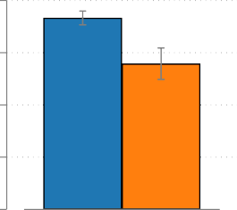6

5

Years of Schooling

 Not in child labour

4  In child labour

3

2

.5

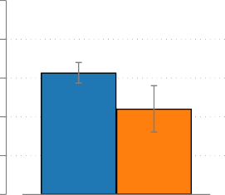.4

.3  Not in child labour

 In child labour

.2

.1

0

(c) Sesotho reading skills (d) Numeracy skills

% with Foundational Sesotho Reading Skills

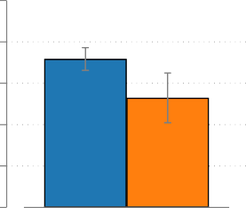.5

.4

.3  Not in child labour

 In child labour

.2

.1

0

.5

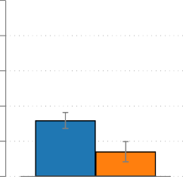.4

% with Foundational Numeracy Skills

.3  Not in child labour

 In child labour

.2

.1

0

*Source*: Own representation using Lesotho MICS 2018 data. *Notes*: Sample is the children aged 5-17 years, except for the foundational learning skills, where the sample is the children aged 7-14 years.

## Descriptive Analysis

## Table 2 — Summary Statistics by Child Labour Participation Status

Not in Child Labour In Child Labour

|  |  |  |  |  |  |  |  |
| --- | --- | --- | --- | --- | --- | --- | --- |
| Variables | N | Mean | SD |  | N | Mean | SD |
| Years of Schooling | 3,154 | 5.67 | 2.86 |  | 514 | 4.79 | 2.57 |
| Foundational English reading skills | 2,064 | 0.31 | 0.46 |  | 377 | 0.22 | 0.42 |
| Foundational Sesotho reading skills | 2,064 | 0.36 | 0.48 |  | 377 | 0.26 | 0.44 |
| Foundational Numeracy skills | 1,958 | 0.16 | 0.37 |  | 342 | 0.07 | 0.26 |
| Female | 3,194 | 0.55 | 0.50 |  | 522 | 0.38 | 0.49 |
| Mother education: None or Primary | 3,101 | 0.62 | 0.49 |  | 508 | 0.70 | 0.46 |
| Mother education: Secondary | 3,101 | 0.31 | 0.46 |  | 508 | 0.26 | 0.44 |
| Mother education: Tertiary | 3,101 | 0.07 | 0.26 |  | 508 | 0.03 | 0.18 |

*Source:* Own calculations using Lesotho 2018 MICS data. *Notes*: The sample is children aged 5-17 years, except for foundational learning skills, where the sample is children aged 7-14 years.

Table 2 presents the summary statistics of key variables by child labour participation status. The data reveal that the children engaged in child labour consistently exhibit poorer educational outcomes compared to their peers who are not. Specifically, the children in child labour have, on average, 0.88 fewer years of schooling. Table 2 also shows that 38% of the children involved in child labour are female, and 55% of those not engaged in child labour are female. Only 7% of these children possess foundational numeracy skills; 22% demonstrate foundational English reading skills; and 26% exhibit foundational Sesotho reading skills; compared to 16%, 31%, and 36%, respectively, amongst the children not involved in child labour. This result is clearly seen in Figure 2, which shows that child labour participation decreases as the mother’s level of education increases. This suggests that child labour is high in poor households (that is, those with low maternal education), potentially due to economic pressures and/or a lack of awareness regarding the value of education, and low in rich households (that is, those with high maternal education). Therefore, higher maternal education (or more resources) appears to have a protective effect against child labour.

## Figure 2 — Child Labour by Mother’s Level of Education

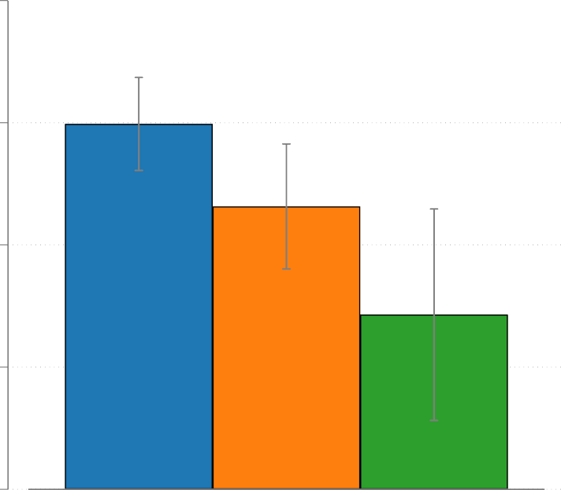.2

.15

Child Labour Participation (%)





.1

.05

0

Primary or none Secondary Higher

*Source*: Own representation using Lesotho MICS 2018 data. *Notes:* Sample is the children aged 5-17 years, except for the foundational learning skills, where the sample is the children aged 7-14 years.

**Table 3 — Summary Statistics by Child Labour Participation Status**

Boys Girls

|  |  |  |  |  |  |  |  |
| --- | --- | --- | --- | --- | --- | --- | --- |
| Variables | N | Mean | SD |  | N | Mean | SD |
| Years of Schooling | 2,426 | 4.84 | 2.84 |  | 2,434 | 5.17 | 3.17 |
| Foundational English reading skills | 1,568 | 0.21 | 0.40 |  | 1,540 | 0.33 | 0.47 |
| Foundational Sesotho reading skills | 1,568 | 0.25 | 0.43 |  | 1,540 | 0.37 | 0.48 |
| Foundational Numeracy skills | 1,411 | 0.11 | 0.32 |  | 1,418 | 0.15 | 0.36 |
| Child labour | 1,747 | 0.18 | 0.38 |  | 1,969 | 0.10 | 0.30 |
| Mother education: None or Primary | 2,465 | 0.64 | 0.48 |  | 2,408 | 0.62 | 0.49 |
| Mother education: Secondary | 2,465 | 0.30 | 0.46 |  | 2,408 | 0.30 | 0.46 |
| Mother education: Tertiary | 2,465 | 0.06 | 0.24 |  | 2,408 | 0.08 | 0.27 |

*Source:* Own calculations using Lesotho 2018 MICS data. *Notes*: The sample is children aged 5-17 years, except for foundational learning skills, where the sample is children aged 7-14 years.

Table 3 presents the summary statistics, disaggregated by gender. The average of the completed years of schooling for the girls is 5.17 years, compared to an average completion of 4.84 years for the boys. 3 In addition, it highlights the differences in maternal education levels between the children engaged in child labour and those who are not. Amongst the children involved in child labour, 62% of girls have their mothers who have no education or only primary education; 30% have secondary education; and just 8% have tertiary education. In contrast, for the boys involved in child labour, 64% of their mothers have no education or primary education; 30% have secondary education; and 6% have tertiary education.

Figure 3 shows the relationship between child labour and educational outcomes disaggregated by gender. First, the figure reveals that, on average, more girls possess foundational learning skills and have more years of schooling than boys. These results highlight gender disparity in child labour, with more boys involved in labour than girls. On the one hand, from panels (a)-(d), we can see that there are no statistically significant differences in education outcomes of girls involved in child labour compared to those not involved in child labour.

1. We can also find that more boys (18%) are engaged in child labour compared to girls (10%).

**Figure 3 — Child Labour, Educational Outcomes by Gender**

1. 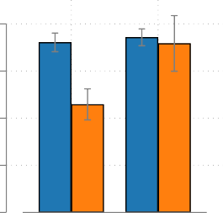Years of Schooling

6

1. English reading skills

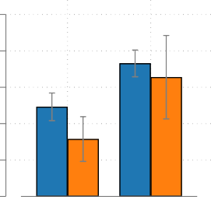.5

% with Foundational English Reading Skills

5

Years of Schooling

4

3

2 Boys Girls

 Not in child labour  In child labour

.4

.3

.2

.1

0 Boys Girls

 Not in child labour  In child labour

1. Sesotho reading skills (d) Numeracy skills

% with Foundational Sesotho Reading Skills

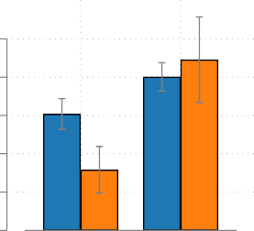.5

.4

.3

.2

.1

0 Boys Girls

 Not in child labour  In child labour

.5

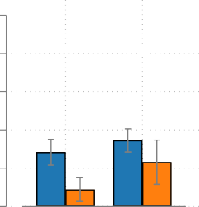.4

% with Foundational Numeracy Skills

.3

.2

.1

0 Boys Girls

 Not in child labour  In child labour

*Source*: Own representation using Lesotho MICS 2018 data. *Notes:* Sample is the children aged 5-17 years, except for the foundational learning skills, where the sample is the children aged 7-14 years.

On the other hand, the child labour’s association with education outcomes are concentrated amongst the boys: the boys who are engaged in child labour have significantly lower years of schooling, foundational reading, and foundational numeracy skills. This may partly be related to factors such as the gendered division of labour and social expectations: boys are doing heavier or more time-consuming labour tasks (for example, herding animals) that significantly compromise their schooling, whereas girls are performing mostly household chores in addition to attending school, although sometimes with difficulty.

In sum, the preliminary evidence presented in this section shows a strong negative correlation between child labour participation and learning outcomes. There are more boys involved in child labour than girls, and boys have, on average, worse educational outcomes than girls. This is largely driven by the learning outcomes of the boys engaged in child labour. While these results are intuitive and largely consistent with some prior literature and widely held views in the international policy discourse, they are not causal. In the next section, we describe the empirical strategy that we use to tease out the cause-effect of child labour.

# — Empirical Strategy

This paper aims to estimate the average causal impact of child labour on educational outcomes-attainment and foundational skills. We adopt the non-parametric bounds method from

Manski (1989, 1990, 1995) and Manski & Pepper (2000). This method is well-suited for causal identification with cross-sectional data, where it is often difficult to find a credible causal point identification strategy.

This section details how to partially identify the causal effect of child labour with the non-parametric bounds approach. We draw heavily from De Haan (2017, 2011) and Germinario et al. (2022) to explain how this strategy works. The average treatment effect (ATE) can be stated as follows:

∆(*t* = 1*, t* = 0) = E[*y*(*t* = 1)] − E[*y*(*t* = 0)] (1)

where *y* is the outcome of interest, for example, the child’s completed years of schooling or foundational skills; and *t* is the treatment variable, which equals 1 if a child is in child labour and 0 otherwise. Thus, ATE is the difference between two potential outcomes - the average education observed when a child is in child labour ( E[*y*(*t* = 1)]) and the education observed when a child is not in child labour ( E[*y*(*t* = 0)]). However, the identification of the ATE is difficult because we can only observe a child in either of the two states - in child labour or not in child labour - at any point in time. Therefore, the potential outcome *y*(*t* = 1) is unobserved for the children who are not in child labour, and the potential outcome *y*(*t* = 0) is unobserved for the children in child labour. This identification problem can be highlighted by using the Law of Iterated Expectations to write the expected potential outcome E[*y*(*t* = 1)] as follows:

E[*y*(*t* = 1)] = E[*y*|*z* = 1] · P[*z* = 1] + E[*y*(*t* = 1)|*z* = 0] · P[*z* = 0] (2)

where *z* is the treatment (child labour status) a child actually received; P[*z* = 1] and P[*z* = 0] are the probabilities of participating and not participating in child labour, respectively. To simplify the notation, we replace E[*y*(*t* = 1)|*z* = 1] with E[*y*|*z* = 1].

The data contains information on *y* and can identify the sample analogues of all the

quantities on the right side ( E[*y*|*z* = 1], P[*z* = 1], and P[*z* = 0]) except the counterfactual average educational outcome for the children who are in child labour if they had not been in child labour, E[*y*|*z* = 0]. We can also decompose the average treatment effect E[*y*(*t* = 0)] and obtain similar results.

Manski (1989) shows that we can bound the average treatment effect using only the available data without imposing any additional assumptions as long as the dependent variable is bounded.

Manski (1989) suggests substituting the unobserved potential outcomes, E[*y*(*t* = 1)|*z* = 0]

and E[*y*(*t* = 0)|*z* = 1], with the minimum value (*ymin*) of the outcome variable to get the

lower bounds on E[*y*(*t* = 1)] and E[*y*(*t* = 0)], and then substituting the potential outcomes with the maximum value (*ymax*) to the upper bounds:

E[*y*|*z* = 1] · P[*z* = 1] + *ymin* · P[*z* = 0]

≤ E[*y*(*t* = 1)] ≤

E[*y*|*z* = 1] · P[*z* = 1] + *ymax* · P[*z* = 0]

(3)

E[*y*|*z* = 0] · P[*z* = 0] + *ymin* · P[*z* = 1]

≤ E[*y*(*t* = 0)] ≤

E[*y*|*z* = 0] · P[*z* = 0] + *ymax* · P[*z* = 1]

Therefore, from equation 3, we get the no-assumption lower (respectively, upper) bound on the ATE ∆(*t*=1*,t*=0) by subtracting the upper (lower) bound of E[*y*(*t* = 0)] from the lower (upper) bound of E[*y*(*t* = 1)]. Therefore, the no-assumption (worse-case) bounds are as follows:

E[*y*|*z* = 1] · P[*z* = 1] + *ymin* · P[*z* = 0] − E[*y*|*z* = 0] · P[*z* = 0] − *ymax* · P[*z* = 1]

≤ ∆(*t*=1*,t*=0) ≤

E[*y*|*z* = 1] · P[*z* = 1] + *ymax* · P[*z* = 0] − E[*y*|*z* = 0] · P[*z* = 0] − *ymin* · P[*z* = 1]

(4)

The true value of the causal impact of child labour on schooling should fall within these no-assumption bounds. These bounds are, however, very wide and can be uninformative. To tighten these bounds, and approximate the true causal effect of child labour on educational outcomes, we layer three relatively weak non-parametric bounds assumptions - the monotone treatment selection, monotone treatment response, and monotone instrumental variable assumptions - introduced by Manski & Pepper (1998) and Manski & Pepper (2000).

## Monotone Treatment Selection Assumption (MTS)

The MTS assumption captures the notion that the children who "self-selected" child labour (*t* = 1) have lower potential schooling outcomes. Thus, the MTS assumption states that the average educational outcome that would be observed for children participating in child labour should be lower or equal to those who do not if we compare two groups: the children participating in child labour (*z* = 1) and those who are not participating (*z* = 0). Formally, the non-positive MTS assumption states that,

E[*y*|*z* = 1] ≤ E[*y*|*z* = 0] (5)

Equation 5 states that if all the children were to participate in child labour (*t* = 1 or *t* = 0), those who are currently participating in child labour (*z* = 1) will, on average, not perform better than those who are currently none participants (*z* = 0). We cannot test this assumption because some potential outcomes are counterfactual. However, given that most evidence points to zero or detrimental effects of child labour on educational outcomes, we consider this assumption plausible in our case. Further, our data provides indirect support to the plausibility of this assumption as it shows that the children in child labour have worse educational outcomes than those not in child labour (see Table 1 and Figure 1). Under the MTS assumption, the potential average education of children who are currently not in child labour, if they were to participate, they will not be lower than the observed average education of those actually participating in child labour. Therefore, we can tighten the bounds for E[*y*(*t* = 1)] in equation 3 by using E[*y*(*t*)|*z* = 1] as the lower bound and, analogously, use E[*y*(*t*)|*z* = 0] as the upper bound on the average potential education of not being in child labour ( E[*y*(*t* = 0)]).

Therefore, the MTS bounds can be written as follows:

E[*y*|*z* = 1]

≤ E[*y*(*t* = 1)] ≤

E[*y*|*z* = 1] × P[*z* = 1] + *ymax* × P[*z* = 0]

(6)

E[*y*|*z* = 0] × P[*z* = 0] + *ymin* × P[*z* = 1]

≤ E[*y*(*t* = 0)] ≤

E[*y*|*z* = 0]

As before, the lower (respectively, upper) bound on the ATE ∆(*t*=1*,t*=0) is calculated by subtracting the upper (lower) bound of E[*y*(*t* = 0)] from the lower (upper) bound of E[*y*(*t* = 1)] resulting in the following:

E[*y*|*z* = 1] − E[*y*|*z* = 0]

≤ ∆(*t*=1*,t*=0) ≤

E[*y*|*z* = 1] × P[*z* = 1] + *ymax* · P[*z* = 0] − E[*y*|*z* = 0] · P[*z* = 0] − *ymin* × P[*z* = 1]

(7)

## Monotone Treatment Response Assumption (MTR)

The MTR assumption assumes that participating in child labour does not increase education outcomes (Manski & Pepper, 2000, 2009). Formally, for each child and any treatment levels *t*0, *t*1,

*t*1 ≥ *t*0 =⇒ *y*(*t* = 1) ≤ *y*(*t* = 0) (8)

This assumes that all the children participating in child labour have weakly worse educational outcomes. This might not hold for some individuals. However, consistent with most of the literature, this might hold on average. Fortunately, in our case, the MTR assumption is implied by the MTS assumption because the treatment (child labour) is binary. The MTS bounds are exactly the same. Therefore, it does not help us much to narrow the bounds.

## Monotone Instrumental Variable Assumption (MIV)

The MTS bounds are further narrowed by layering the monotone instrumental variable (MIV) assumption. An MIV is a variable with a monotone (weakly positive or negative) mean relationship with potential education. Therefore, unlike the strong exclusion restriction in Instrumental Variable (IV) models, which requires an IV that is orthogonal to education, the MIV assumption is weaker. Further, under the MIV assumption, there is no requirement for the variable to have a causal effect on the outcome (education).

Assuming that the data includes information on child labour participation, education outcomes, and another variable *ν* satisfying the following weakly increasing MIV assumption, we can tighten the bounds. Specifically, *ν* is considered the valid MIV if it satisfies the following assumption (Manski & Pepper, 2000, 2009):

*m*1 ≤ *m* ≤ *m*2 =⇒ E[*y*(*t*)|*ν* = *m*1] ≤ E[*y*(*t*)|*ν* = *m*] ≤ E[*y*(*t*)|*ν* = *m*2]*, t* = 0*,* 1 (9)

In this paper, we use the mother’s highest level of education attained as a MIV, which we consider to be a valid MIV because increasing a the mother’s education level by a year increases the probability of a child completing more years of schooling (De Haan, 2011). Unlike fathers, mothers tend to have higher levels of involvement in their children’s education. Figure 2 shows a strong negative relationship between mothers’ education and child labour participation. We divide the mother’s educational level into three categories - primary or no education, secondary education, and tertiary education - and compute the MTS bounds within each level of education.

Equation 9 implies that the lower bound on E[*y*(*t* = 1)|*ν* = *m*] is no lower than the lower

bound on E[*y*(*t* = 1)|*ν* = *m*1] and it is no higher than the upper bound on E[*y*(*t* = 1)|*ν* = *m*2].

For the sub-sample where *ν* has a value of *m*, we can thus obtain a new lower bound on the mean potential education of being in child labour. This can be done by taking the largest lower

bound over all the bins where *ν* ≤ *m*. Similarly, we can obtain a new upper bound by taking

the smallest upper bound over all the sub-samples where *ν* ≥ *m*. The MIV + MTS bounds are then obtained by taking the weighted average of the MIV bounds over *ν* (which follows from

the law of iterated expectations):

Σ

*m*∈*M*

Σ

*m*∈*M*

P[*ν* = *m*] × [*maxm*1≤*mLB* E[*y*(*t*=1)|*ν*=*m*1]]

≤ E[*y*(*t* = 1)] ≤

P[*ν* = *m*] × [*minm*2≥*mUB* E[*y*(*t*=1)|*ν*=*m*2]]

(10)

where *LB* is the MTS lower bound from equation 6 on E[*y*(*t* = 1)] at values *ν* = *m*1 of the MIV, and *UB* is the MTS upper bound on E[*y*(*t* = 1)] at values *ν* = *m*2 of the MIV. Once again, the MIV+MTS lower (upper) bound on the ATE ∆(*t*=1*,t*=0) is calculated by subtracting the upper (lower) bound of E[*y*(*t* = 0)] from the lower (upper) bound of E[*y*(*t* = 1)] and gives us the following:

Σ P[*ν* = *m*] × [*maxm*1≤*mLB* E[*y*(*t*=1)|*ν*=*m*1]] − Σ P[*ν* = *m*] × [*minm*2≥*mUB* E[*y*(*t*=0)|*ν*=*m*2]]

*m*∈*M m*∈*M*

≤ ∆(*t*=1*,t*=0) ≤

Σ

*m*∈*M*

P[*ν* = *m*] × [*minm*2≥*mUB* E[*y*(*t*=1)|*ν*=*m*2]] − Σ

*m*∈*M*

P[*ν* = *m*] × [*maxm*1≤*mLB* E[*y*(*t*=0)|*ν*=*m*1]]

(11)

## Estimation and Inference

We estimate the non-assumption and MTS bounds by plugging in sample means and probabilities in the corresponding expressions of the bounds. Since the plug-in estimators in equation 10 are potentially biased in finite samples, thus making them narrower relative to the corresponding true identified set, and the corresponding confidence intervals do not have the expected coverage of the desired level. We follow De Haan (2017) and perform inference by constructing Imbens & Manski (2004) confidence intervals. The 95% confidence interval is given as follows:

*CI*0*.*95 = (*l*ˆ*b* − *CIM* × *σ*ˆ*lb, u*ˆ*b* + *CIM* × *σ*ˆ*ub*) (12) where *l*ˆ*b* and *u*ˆ*b* are the estimated lower and upper bounds, respectively. *σ*ˆ*lb* and *σ*ˆ*ub* are

the estimated standard errors of the lower and upper bounds that are estimated through 1000 bootstrap replications. We estimated the parameter *CIM* by solving the following equation:

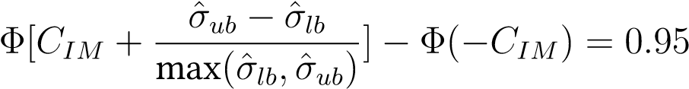 (13)

# — Results and Discussions

## Main Results

This section presents the non-parametric bounds of the impact of child labour on the completed years of schooling and foundational learning skills: English reading skills, Sesotho reading skills, and numeracy skills. First, we present the main results and then the results disaggregated by the child’s gender.

Figure 4 presents the non-parametric bounds around the impact of child labour on the completed years of schooling. The y-axis is the average treatment effect, and the x-axis shows the point estimate of average treatment effect (ATE), and the non-parametric bounds on the effect of child labour on educational attainment under different assumptions. The no-assumption bounds (NOAS), the monotone treatment selection (MTS), and the combination of MTS and monotone instrumental variable (MTS-MIV). The bias-corrected 95% confidence interval is in parentheses.

The results reveal that the average treatment effect of child labour on the years of schooling

is −0*.*88 years, which is a statistically significant negative impact. However, this estimate may be biased and hence an unreliable causal effect of child labour on educational achievement due to the non-random participation in child labour.

We then present the no-assumption (worse-case) bounds in Figure 4, which show us what can be learned about the causal effect using only the available data without imposing additional assumptions. We produce these no-assumption bounds by substituting the unobserved outcomes with the minimal (0) and maximal (12) years of schooling completed by a child. The no-assumption bounds indicate that the causal effect of child labour on education is within [−5*.*90*,* 6*.*13], which is too wide and uninformative. We then add the MTS assumption, which means that the years of schooling are non-increasing in child labour. This assumption reduces the lower bound to −0*.*88, which is equal to the average treatment effect, while the upper bound remains at 6*.*13.

To further tighten these bounds, we use the mother’s education as a MIV and combine it with the MTS assumption. This tightens the bounds to [−0*.*78*,* 5*.*67], which still includes zero,

## Figure 4 — Impact of Child Labour on Educational Attainment

6

Completed years of schooling

−0.88

(−1.20 −0.56)

−0.88 6.13

(−0.56 6.25)

−0.78 5.67

(−0.49 5.79)

−5.90 6.13

(−5.77 6.25)

4

2

E[ Y(t=1) ] − E[ Y(t=0) ]

0

−2

−4

−6

−8

ATE

NOAS

MTS

*Source*: Own representation using Lesotho MICS 2018 data. *Notes*: ATE is the average treatment effect; the NOAB is the no-assumption bounds; the MTS is the monotone instrumental variable; and the MTS-MIV combines monotone treatment selection and monotone instrumental variable. The bootstrap bias-correcting method, suggested by Kreider & Pepper (2007). Imbens & Manski (2004) approach, with 1000 bootstrap replications was used to get 95% confidence intervals (in parentheses).

MTS−MIV

and cannot be narrowed any further with the available data. It also includes zero within these bounds, showing that, the causal effect of child labour on schooling is ambiguous in Lesotho. Figure 5 presents the results for the causal effect of child labour on the foundational numeracy skills. We follow a similar procedure as in Figure 4 above to produce these results. Again, we find a statistically significant average treatment effect (ATE) of −0*.*09, implying that child labour reduces the proportion of the children with foundational numeracy by 9 percentage points. Again, this is potentially biased, hence, we report the bounds for the MTS-MIV. We can see that, although the tighter MTS-MIV bounds [−0*.*08*,* 9*.*28] exclude the ATE, they are still wide and include zero. This suggests that the effect of child labour on foundational numeracy skills is inconclusive; it can reduce the proportion of numeracy skills

by 8 percentage points or increase it by as much as 928 percentage points.

## Figure 5 — Impact of Child Labour on Numeracy

10

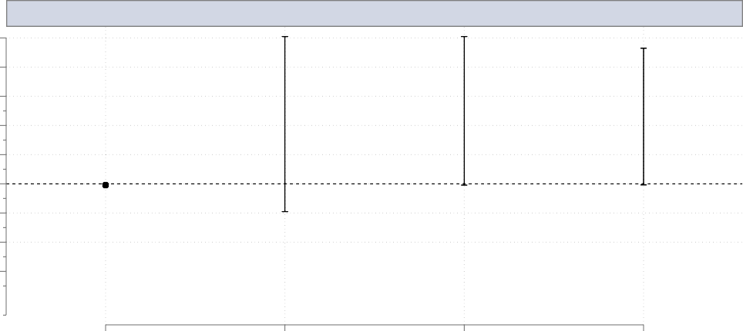

−0.09

(−0.12 −0.05)

−0.09 10.04

−0.08 9.28

−1.91 10.09

(−0.12 10.23)

(−0.11 9.46)

(−2.05 10.23)

Foundational Numeracy Skills

8

6

4

E[ Y(t=1) ] − E[ Y(t=0) ]

2

0

−2

−4

−6

ATE

NOAS

MTS

*Source*: Own representation using Lesotho MICS 2018 data. *Notes*: ATE is the average treatment effect; the NOAB is the no-assumption bounds; the MTS is the monotone instrumental variable; and the MTS-MIV combines monotone treatment selection and monotone instrumental variable. The bootstrap bias-correcting method is suggested by Kreider & Pepper (2007). Imbens & Manski (2004) approach, with 1000 bootstrap replications was used to get 95% confidence intervals (in parentheses).

MTS−MIV

Figures 6 and 7 display the estimated impact of child labour on the foundational English and Sesotho reading skills, respectively. In Figure 6, the estimated Average Treatment Effect (ATE) of child labour on the foundational English reading skills is −0*.*09, suggesting a slight negative impact. However, the tighter the MTS-MIV bounds of [−0*.*07*,* 9*.*12] indicate considerable ambiguity, encompassing a wide range of potential effects, including zero.

## Figure 6 — Impact of Child Labour on Foundational English Reading

10



−0.09

(−0.16 −0.03)

−0.09 9.92

−2.11 9.92

(−0.15 10.06)

−0.07 9.12

(−0.12 9.26)

(−2.25 10.06)

Foundational English Reading Skills

8

6

4

E[ Y(t=1) ] − E[ Y(t=0) ]

2

0

−2

−4

−6

ATE

NOAS

MTS

*Source*: Own representation using Lesotho MICS 2018 data. *Notes*: ATE is the average treatment effect; the NOAB is the no-assumption bounds; the MTS is the monotone instrumental variable; and the MTS-MIV combines monotone treatment selection and monotone instrumental variable. The bootstrap bias-correcting method is suggested by Kreider & Pepper (2007). Imbens & Manski (2004) approach, with 1000 bootstrap replications was used to get 95% confidence intervals (in parentheses).

MTS−MIV

Similarly, Figure 7 reports an ATE of −0*.*09 for foundational Sesotho reading skills, with MTS-MIV bounds of [−0*.*07*,* 9*.*09], further underscoring the uncertainty. While these data hint at a minor negative effect of child labour on reading skills, the bounds allow for the possibility of no or even a positive effect, rendering the results inconclusive overall.

## Figure 7 — The Results on the Average Impact of Child Labour on Foundational Sesotho Reading

10



−0.09

(−0.16 −0.03)

−0.09 9.89

−0.07 9.09

−2.14 9.89

(−0.15 10.03)

(−0.13 9.24)

(−2.14 10.03)

Foundational Sesotho Reading Skills

8

6

4

E[ Y(t=1) ] − E[ Y(t=0) ]

2

0

−2

−4

−6

ATE

NOAS

MTS

*Source*: Own representation using Lesotho MICS 2018 data. *Notes*: ATE is the average treatment effect; the NOAB is the no-assumption bounds; the MTS is the monotone instrumental variable; and the MTS-MIV combines monotone treatment selection and monotone instrumental variable. The bootstrap bias-correcting method, suggested by Kreider & Pepper (2007). Imbens & Manski (2004) approach, with 1000 bootstrap replications was used to get 95% confidence intervals (in parentheses).

MTS−MIV

Overall, our findings suggest that the average effect of child labour on various educational outcomes is inconclusive, although in some cases, the bounds predominantly lie in the positive region. These results align with prior evidence from Phoumin (2008); Kana et al. (2010); Zabaleta (2011); and Dumas (2012), which indicates that the impact of child work on education is context-dependent. Specifically, some studies have found that below a certain threshold, child work does not adversely affect educational outcomes Phoumin (2008); Zabaleta (2011); Dumas (2012), and they are consistent with the theoretical predictions of Fan (2004). Similarly, Kana et al. (2010) report no causal effect of child work on schooling. These prior studies typically measure child labour using the hours of work. Nonetheless, we employ the ILO definition to measure child labour; as a result, our findings may converge because, in Lesotho, the children engaged in child labour are likely working below the critical tipping point at which their effects on education would become distinctly negative.

Beyond methodological differences, another possible explanation for the discrepancy between our findings and prior evidence, which often shows a negative correlation between child labour and educational outcomes (Kassouf et al., 2020; Lee et al., 2021; Keane et al., 2022). This lies in the context of low-income settings like Lesotho. In such environments, child labour and education may function as complementary activities. Specifically, the income generated from child labour might help finance schooling, as suggested by De Hoop et al. (2019). In these cases, the adverse effects of child labour — such as fatigue and reduced time for studying

— could be mitigated by the positive impact of increased financial resources dedicated to education.

## Heterogeneity Analysis by Child’s Gender

This sub-section shows the heterogeneity analysis of the impact of child labour on educational outcomes-attainment and foundational skills by the child’s gender. The y-axis is the average treatment effect, and the x-axis shows the point estimate (ATE) and assumptions of the non-parametric bounds used to examine the effect of child labour on educational attainment. The ATE is the average treatment effect; the NOAB is the no-assumption bounds; the MTS is the monotone instrumental variable; and the MTS-MIV combines monotone treatment selection and monotone instrumental variable.

The presented bounds are bias-corrected using the bootstrap bias-correcting method suggested by Kreider & Pepper (2007). The bootstrap bias-correction method addresses the biases generated by imposing all the non-parametric assumptions because of using the sub-samples in the data. The 95% confidence interval (in the parentheses) is used to address the selection bias in the sample. The confidence intervals show that the true effect or the bounds should be within the confidence interval after controlling for the bias. The 1000 bootstrap replications show that the sampling is done with replacement 1000 times for the non-parametric bound results to be consistent. Child labour’s effects may differ due to different genders’ work activities (Kimane, 2005; Metsing et al., 2020; Mokuku & Mokuku, 2004).

In this sub-section, we follow the same procedure as shown in Figure 4.

## Figure 8 — The Average Impact of Child Labour on Completed Years of Schooling for Girls and Boys

6 6

Girls Completed years of schooling

−0.13 6.23 −0.12 5.72

−0.13

(−0.71 5.87)

(−0.75 0.50)

(−0.66 6.37)

−5.79 6.23

(−5.93 6.37)

Boys Completed years of schooling

−1.32

(−1.69 −0.94)

−1.32 6.00 −1.15 5.60

(−1.63 6.15) (−1.65 5.76)

−6.03 6.00

(−6.18 6.15)

4 4

2 2

0 0

E[ Y(t=1) ] − E[ Y(t=0) ]

E[ Y(t=1) ] − E[ Y(t=0) ]

−2 −2

−4 −4

−6 −6

−8 −8

ATE

NOAS

MTS

MTS−MIV

ATE

NOAS

MTS

MTS−MIV

*Source*: Own representation using Lesotho MICS 2018 data. *Notes*: ATE is the average treatment effect; the NOAB is the no-assumption bounds; the MTS is the monotone instrumental variable; and the MTS-MIV combines monotone treatment selection and monotone instrumental variable. The bootstrap bias-correcting method is suggested by Kreider & Pepper (2007). Imbens & Manski (2004) approach, with 1000 bootstrap replications was used to get 95% confidence intervals (in parentheses).

Figure 8 shows the child labour impact on the completed years of schooling amongst the girls and boys. For the girls, the data show that child labour has an almost negligible effect on the completed years of schooling for the girls aged 5 to 17 years, with an ATE of −0*.*13, and the MTS-MIV of [−0*.*12*,* 5*.*72]. The evidence further underscores the uncertainty about child labour and its relationship with the girls’ educational attainment, as can be seen by the wide and crossing bounds. Conversely, for the boys, the ATE of -1.32 implies that, on average, child labour cuts the number of years of completed education amongst the boys by 1.32. The negative sign agrees with general expectations that child labour reduces the time and energy that the boys can invest in education. The MTS-MIV bounds are much tighter at [−1*.*15*,* 5*.*60]. This tight bound also supports the hypothesis that child labour has a negative effect but also allows for individual differences or minor positive effects.

## Figure 9 — The Average Impact of Child Labour on Numeracy for Girls and Boys

10



−0.06 10.69

−0.06 −1.31 10.69 (−0.11 10.86)

−0.47 9.73

(−0.12 9.91)

(−0.12 0.01)

(−1.47 10.86)

Girls Foundational Numeracy Skills

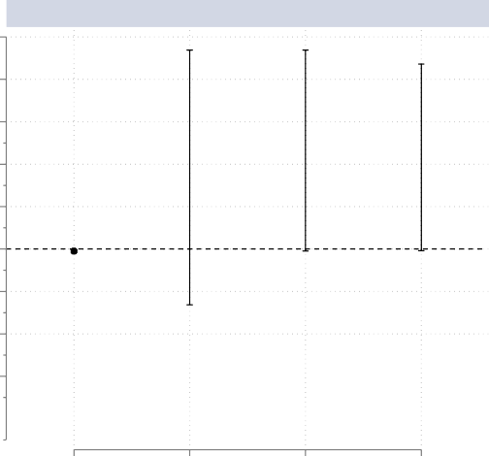

−0.10

−0.10 9.37 −0.07 8.71

(−0.14 −0.05)

(−1.14 9.62) (−0.12 8.97)

−2.63 9.37

(−2.87 9.62)

Boys Foundational Numeracy Skills

10

8

8

6 6

4 4

E[ Y(t=1) ] − E[ Y(t=0) ]

E[ Y(t=1) ] − E[ Y(t=0) ]

2 2

0 0

−2 −2

−4 −4

−6 −6

ATE

NOAS

MTS

ATE

NOAS

MTS

*Source*: Own representation using Lesotho MICS 2018 data. *Notes*: ATE is the average treatment effect; the NOAB is the no-assumption bounds; the MTS is the monotone instrumental variable; and the MTS-MIV combines monotone treatment selection and monotone instrumental variable. The bootstrap bias-correcting method, suggested by Kreider & Pepper (2007). Imbens & Manski (2004) approach, with 1000 bootstrap replications was used to get 95% confidence intervals (in parentheses).

MTS−MIV

MTS−MIV

Figure 9 estimated the ATE of −0*.*06 for the girls. This small negative child labour impact suggests that the girls who are labourers may average a marginal loss in numeracy. As for boys, the data show that child labour in Lesotho is probably slightly negative, but highly uncertain regarding their numeracy skills, with the estimated ATE of −0*.*10 suggesting modest adverse effects. This would reflect the general expectation that child labour could hinder learning due to reduced time and cognitive resources. However, the MTS-MIV bounds of [−0*.*47*,* 9*.*73] for the girls and [−0*.*07*,* 8*.*71] for the boys, respectively, reflect a possible slightly larger negative shock. Therefore, the findings suggest that the overall effect of child labour on numeracy skills for girls and boys is inconclusive in Lesotho.

Moreover, Figure 10 shows the ATE of −0*.*04 and −0*.*09 for English reading skills amongst the girls and boys in child labour, respectively, suggesting negative effects. Again, the MTS-MIV estimate of [−0*.*02*,* 9*.*54] and [−0*.*06*,* 8*.*54] for the girls and boys, correspondingly, reflects a possible larger negative impact, especially for boy children. The consistently wide range

across these estimates underscores the uncertainty.

## Figure 10 — The Average Impact of Child Labour on Foundational English Reading Skills for Girls and Boys

10 10



−0.04

−1.51 10.51

−0.04 10.51 −0.02 9.54

(−0.14 10.66) (−0.10 9.74)

(−0.16 0.08)

(−1.67 10.66)

Girls Foundational English Reading Skills

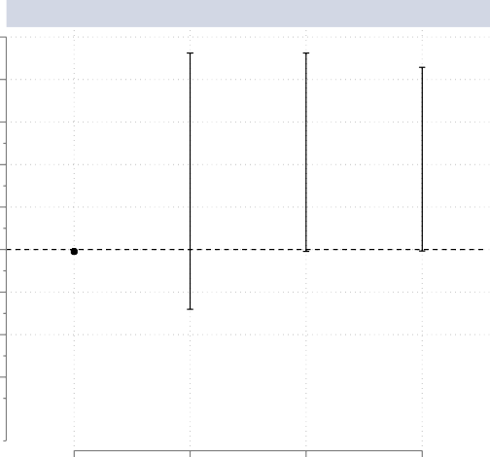

−0.09

(−0.16 −0.02)

−0.09 9.25 −0.06 8.54

(−0.12 8.81)

(−0.15 9.48)

−2.81 9.25

(−3.04 9.48)

Boys Foundational English Reading Skills

8 8

6 6

4 4

E[ Y(t=1) ] − E[ Y(t=0) ]

E[ Y(t=1) ] − E[ Y(t=0) ]

2 2

0 0

−2 −2

−4 −4

−6 −6

ATE

NOAS

MTS

ATE

NOAS

MTS

*Source*: Own representation using Lesotho MICS 2018 data. *Notes*: ATE is the average treatment effect; the NOAB is the no-assumption bounds; the MTS is the monotone instrumental variable; and the MTS-MIV combines monotone treatment selection and monotone instrumental variable. The bootstrap bias-correcting method, suggested by Kreider & Pepper (2007). Imbens & Manski (2004) approach, with 1000 bootstrap replications was used to get 95% confidence intervals (in parentheses).

MTS−MIV

MTS−MIV

Lastly, Figure 11 illustrates the child labour results for both girls and boys on the foundational Sesotho reading skills. On the one hand, the data reports the ATE of 0*.*05 for the girls and the MTS-MIV bounds of [0*.*04*,* 9*.*54], consistent with a positive effect. This reveals that child labour can increase the proportion of the girls’ Sesotho reading skills by at least 4 and at most 954 percentage points. On the other hand, the ATE of −0*.*15 for the boys’ Sesotho reading skills suggest the adverse effects. Again, the MTS-MIV bounds of [−0*.*12*,* 8*.*54] indicate considerable ambiguity amongst the boys. Although the boys may be more affected by child labour, especially in the foundational reading skills, the effects on the girls are less severe, with some signs of a slight positive influence on Sesotho’s reading skills.

## Figure 11 — The Average Impact of Child Labour on Foundational Sesotho Reading Skills for Girls and Boys

10 10

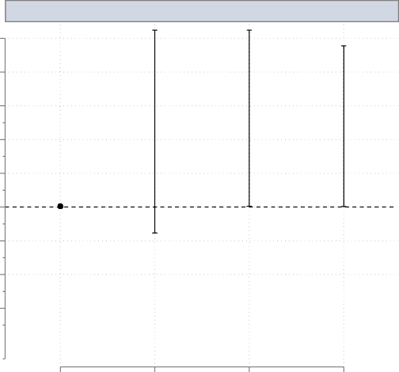

0.05

(−0.07 0.16)

0.05 10.49

−1.53 10.49 (−0.05 10.64)

(−1.68 10.64)

0.04 9.54

(−0.05 9.73)

Girls Foundational Sesotho Reading Skills

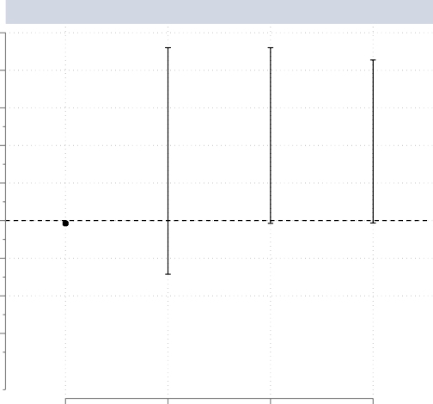

−0.15

(−0.22 −0.07)

−0.15 9.20

−0.12 8.54

(−0.21 9.44)

(−0.18 8.79)

−2.85 9.20

(−3.09 9.44)

Boys Foundational Sesotho Reading Skills

8 8

6 6

4 4

E[ Y(t=1) ] − E[ Y(t=0) ]

E[ Y(t=1) ] − E[ Y(t=0) ]

2 2

0 0

−2 −2

−4 −4

−6 −6

ATE

NOAS

MTS

ATE

NOAS

MTS

*Source*: Own representation using Lesotho MICS 2018 data. *Notes*: ATE is the average treatment effect; the NOAB is the no-assumption bounds; the MTS is the monotone instrumental variable; and the MTS-MIV combines monotone treatment selection and monotone instrumental variable. The bootstrap bias-correcting method, suggested by Kreider & Pepper (2007). Imbens & Manski (2004) approach, with 1000 bootstrap replications was used to get 95% confidence intervals (in parentheses).

MTS−MIV

MTS−MIV

Overall, our heterogeneity analysis suggests that, except for the girls’ foundational Sesotho reading skills, the impacts of child labour on educational outcomes are mixed. The girls’ results agree with the studies, such as Emerson & Knabb (2006); Beegle et al. (2009); Patrinos & Psacharopoulos (1997). They argue that the relationship between child labour and the girls’ educational outcomes may be complex and uncertain, depending on a set of factors that include socio-economic conditions, cultural norms, and access to education. However, the positive effect of child labour on girls’ foundational Sesotho reading skills (see figure11) is consistent with Dumas (2012); Watson (2008), who attribute this to the work activities enhancing human development, such as cashiers improving mathematics skills. This contrasts with the longitudinal studies like Emerson & Souza (2011); Gunnarsson et al. (2006); Le & Homel (2015), which show negative effects, illustrating the complexity of this relationship.

For the boys, our findings support Beegle et al. (2009); Gunnarsson et al. (2006); Emerson & Souza (2011), in emphasising the negative and sometimes indeterminate impact that child labour has on the boys’ education, often due to the reasons of socio-economic status or the quality of the school. However, the studies by Dumas et al. (2008); Phoumin (2008); Watson (2008) found positive effects as hard-physical activities encourage emotional maturity and character development. For example, herding helps the boys build up wealth for later life responsibilities and promotes greater participation in environmental and agricultural education (see Kimane (2005)). However, these findings are inconsistent with the findings of Hamenoo et al. (2018); He (2016); Lee et al. (2021), who find long-term detrimental effects and point out that human capital accumulation is a gradual process.

These results underline the need to consider gender-specific factors since the type of work and its interaction with education differ greatly between the boys and girls.

# — Conclusion

The paper investigates the impact of child labour on educational outcomes in Lesotho, using the data from the Lesotho 2018 Multiple Indicator Cluster Survey. We apply the non-parametric bounds analysis approach to generate the upper and lower bounds of the effects of child labour on education. We find inconclusive results for all the educational outcomes (completed years of schooling, foundational English reading skills, Sesotho reading skills, and Numeracy skills). These results are in contrast with the extant literature, which reveals the positive to no effect and the detrimental effect of child labour on a child’s education. Hence, there is strong evidence that results are mixed and appear to be context-specific.

Moreover, while accounting for endogeneity using a monotone instrumental variable (MIV), we find a strong negative relationship between maternal education and child labour participation for the mother’s education level. This relationship underlines the importance of maternal education in tackling child labour, emphasising the investment in the women’s education as part of the broader socio-economic development goals. Furthermore, we also test for gender-specific effects and find that the societal expectations and responsibilities led to the diverging impact of child labour on boys’ and girls’ education. The findings underline the relevance of considering interventions that target the general and gender-specific implications of child labour on education.

This paper, however, has several limitations. First, the paper relies on the outdated data from 2018, which may not reflect the actual problem, and the results might differ with more up-to-date data. Second, the paper utilises survey data with missing values and possible reporting errors. Response bias reduces the sample size, while non-random sampling results in sample selection bias, where the victims of child labour may be excluded. Last, the cross-sectional nature of the data limits our ability to draw causal inferences, and the reliance on maternal education as the sole instrumental variable constrains the scope of the analysis.

Despite these limitations, our findings suggest that policy interventions must address the gendered differences of the child labour’s effects. For the boys, child labour exerts a more severe negative impact on foundational skills; However, there is a positive association with Sesotho reading for the girls. The efforts towards reducing the burden of market work and household chores for the boys are therefore essential, and this should occur along with strengthened support systems that enhance the girls’ acquisition of skills. Targeted approaches will limit the harmful effects of child labour and ensure equity in education.

Moreover, future research should explore longitudinal data to capture the long-term impacts of child labour on education. Expanding the analysis to parametric methods can enhance causal inference and provide actionable insights into effective intervention.

# References

Amaro, D. & Mizunoya, S. (2020). Toward Achieving Inclusive and Equitable Quality Education for All: A Manual for Statistical Data Analysis using Multiple Indicator Cluster Surveys (MICS6) with a special focus on achieving the Sustainable Development Goals. *United Nations Children’s Fund*.

Baland, J.-M. & Robinson, J. A. (2000). Is Child Labour Inefficient? *Journal of Political Economy*, 108(4), 663–679.

Beegle, K., Dehejia, R., & Gatti, R. (2009). Why Should We Care About Child Labour?: The Education, Labour Market, and Health Consequences of Child Labour. *Journal of Human Resources*, 44(4), 871–889.

Boutin, D. & Jouvin, M. (2022). Child Labour Consequences on Education and Health: A Review of Evidence and Knowledge Gaps.

Chant, S. & Pedwell, C. (2008). Women, Gender and the Informal Economy: An Assessment of ILO Research and Suggested Ways Forward.

De Haan, M. (2011). The Effect of Parents’ Schooling on Child’s Schooling: A Non-Parametric Bounds Analysis. *Journal of Labour Economics*, 29(4), 859–892.

De Haan, M. (2017). The Effect of Additional Funds for Low-ability Pupils: A Non-Parametric Bounds Analysis. *The Economic Journal*, 127(599), 177–198.

De Hoop, J., Friedman, J., Kandpal, E., & Rosati, F. C. (2019). Child Schooling and Child Work in the Presence of a Partial Education Subsidy. *Journal of Human Resources*, 54(2), 503–531.

De Hoop, J. & Rosati, F. C. (2014). Cash Transfers and Child Labour. *The World Bank Research Observer*, 29(2), 202–234.

Delprato, M. & Akyeampong, K. (2019). The Effect of Working on Students’ Learning in Latin America: Evidence from the Learning Survey Terce. *International Journal of Educational Development*, 70, 102086.

Dumas, C. (2012). Does Work Impede Child Learning? The Case of Senegal. *Economic Development and Cultural Change*, 60(4), 773–793.

Dumas, C. et al. (2008). *Does Work Impede Child’s Learning? The Case of Senegal*. Technical Report, THEMA (THéorie Economique, Modélisation et Applications), Université de . . . .

Emerson, P. M. & Knabb, S. D. (2006). Opportunity, Inequality and the Intergenerational Transmission of Child Labour. *Economica*, 73(291), 413–434.

Emerson, P. M., Ponczek, V., & Souza, A. P. (2017). Child Labour and Learning. *Economic Development and Cultural Change*, 65(2), 265–296.

Emerson, P. M. & Souza, A. P. (2011). Is Child Labour Harmful? The Impact of Working Earlier in Life on Adult Earnings. *Economic Development and Cultural Change*, 59(2), 345–385.

Fan, C. S. (2004). Relative Wage, Child Labour, and Human Capital. *Oxford Economic Papers*, 56(4), 687–700.

Germinario, G., Amin, V., Flores, C. A., & Flores-Lagunes, A. (2022). What Can We Learn About the Effect of Mental Health on Labour Market Outcomes Under Weak Assumptions? Evidence from the NLSY79. *Labour Economics*, 79, 102258.

Gunnarsson, V., Orazem, P. F., & Sánchez, M. A. (2006). Child Labor and School Achievement in Latin America. *The World Bank Economic Review*, 20(1), 31–54.

Gust, S., Hanushek, E. A., & Woessmann, L. (2024). Global Universal Basic Skills: Current Deficits and Implications for World Development. *Journal of Development Economics*, 166, 103205.

Haile, G. & Haile, B. (2012). Child Labour and Child Schooling in Rural Ethiopia: Nature and Trade-off. *Education Economics*, 20(4), 365–385.

Hamenoo, E. S., Dwomoh, E. A., & Dako-Gyeke, M. (2018). Child Labour in Ghana: Implications for Children’s Education and Health. *Children and Youth Services Review*, 93, 248–254.

He, H. (2016). Child Labour and Academic Achievement: Evidence from Gansu Province in China.

*China Economic Review*, 38, 130–150.

ILO & UNICEF (2021). *Child Labour: Global Estimates 2020, Trends and the Road Forward*. New York: ILO and UNICEF, License: CC BY 4.0.

Imbens, G. W. & Manski, C. F. (2004). Confidence Intervals for Partially Identified Parameters.

*Econometrica*, 72(6), 1845–1857.

Kana, M., Phoumin, H., & Seiichi, F. (2010). Does Child Labour Have a Negative Impact on Child Education and Health? A Case Study in Rural Cambodia. *Oxford Development Studies*, 38(3), 357–382.

Kassouf, A. L., Tiberti, L., & Garcias, M. (2020). Evidence of the Impact of Children’s Household Chores and Market Labour on Learning from School Census Data in Brazil. *The Journal of Development Studies*, 56(11), 2097–2112.

Keane, M., Krutikova, S., & Neal, T. (2022). Child Work and Cognitive Development: Results from Four Low to Middle-Income Countries. *Quantitative Economics*, 13(2), 425–465.

Kimane, I. (2005). Protecting Orphaned Children Through Legislation: The Case of Lesotho. In *4th World Congress on Family Law and Children’s Rights* (pp. 20–23).

Kreider, B. & Pepper, J. V. (2007). Disability and Employment: Reevaluating the Evidence in Light of Reporting Errors. *Journal of the American Statistical Association*, 102(478), 432–441.

Le, H. T. & Homel, R. (2015). The Impact of Child Labour on Children’s Educational Performance: Evidence from Rural Vietnam. *Journal of Asian Economics*, 36, 1–13.

Lee, J., Kim, H., & Rhee, D.-E. (2021). No Harmless Child Labour: The Effect of Child Labour on Academic Achievement in Francophone Western and Central Africa. *International Journal of Educational Development*, 80, 102308.

Lekhetho, M. (2013). The Impact of Free Primary Education on Access and Quality of Primary Education in Lesotho. *International Journal of Educational Sciences*, 5(4), 397–405.

Manski, C. F. (1989). Anatomy of the Selection Problem. *Journal of Human Resources*, (pp.

343–360).

Manski, C. F. (1990). Non-Parametric Bounds on Treatment Effects. *The American Economic Review*, 80(2), 319–323.

Manski, C. F. (1995). *Identification Problems in the Social Sciences*. Harvard University Press. Manski, C. F. (2011). Policy Analysis with Incredible Certitude. *The Economic Journal*, 121(554),

F261–F289.

Manski, C. F. (2019). Communicating Uncertainty in Policy Analysis. *Proceedings of the National Academy of Sciences*, 116(16), 7634–7641.

Manski, C. F. & Pepper, J. V. (1998). Monotone Instrumental Variables with An Application to the Returns to Schooling.

Manski, C. F. & Pepper, J. V. (2000). Monotone Instrumental Variables, with An Application to the Returns to Schooling. *Econometrica*, 68(4), 997–1012.

Manski, C. F. & Pepper, J. V. (2009). More on Monotone Instrumental Variables. *The Econometrics Journal*, 12(suppl_1), S200–S216.

Metsing, N. E. et al. (2020). *Evaluating the Practice of Child Labour in Lesotho and Identifying Strategies to Provide for Better Protection*. PhD thesis, University of Pretoria.

Mokuku, T. & Mokuku, C. (2004). The Role of Indigenous Knowledge in Biodiversity Conservation in the Lesotho Highlands: Exploring Indigenous Epistemology. *Southern African Journal of Environmental Education*, 21, 37–49.

Moshoeshoe, R. (2023). Long-term Effects of Primary Education Expansion on Educational Achievement. *Annals of Economics and Statistics*, (149), 3–38.

Moshoeshoe, R., Ardington, C., & Piraino, P. (2019). The Effect of the Free Primary Education Policy on School Enrolment and Relative Grade Attainment in Lesotho. *Journal of African Economies*, 28(5), 511–532.

Mussa, E. C., Mirzabaev, A., Admassie, A., Nshakira-Rukundo, E., & von Braun, J. (2019). Does Childhood Work Impede Long-term Human Capital Accumulation? Empirical Evidence from Rural Ethiopia. *International Journal of Educational Development*, 66, 234–246.

Patrinos, H. A. & Psacharopoulos, G. (1997). Family Size, Schooling and Child Labour in Peru–An Empirical Analysis. *Journal of Population Economics*, 10, 387–405.

Phoumin, H. (2008). Human Capital and Hours Worked of Children in Cambodia: Empirical Evidence for Policy Implications. *Asian Economic Journal*, 22(1), 25–46.

Raselimo, M. & Mahao, M. (2015). The Lesotho Curriculum and Assessment Policy: Opportunities and Threats. *South African Journal of Education*, 35(1), 1–12.

UNICEF et al. (2019). Lesotho Multiple Indicator Cluster Survey 2018: Survey Findings Report. In *Lesotho multiple indicator cluster survey 2018: survey findings report* (pp. 434–434).

UNICEF, D. et al. (2018). Monitoring the Situation of Children and Women.

Watson, A. (2008). The Impact of Child Labour on the Educational Achievement of Children in Vietnam. *Young Lives Student Paper, Oxford: Young Lives*.

Zabaleta, M. B. (2011). The Impact of Child Labour on Schooling Outcomes in Nicaragua. *Economics of Education Review*, 30(6), 1527–1539.