Annual Conference of the African Finance and Economic Association (AFEA) and Department of Economics, University of Nairobi, Kenya

Theme: Future of Work: Building a better Africa for tomorrow’s generation through sustainable development and innovation

Sub-themes:

- Infrastructure development

DO ICTs INFRASTRUCTURE REDUCE INFORMAL ECONOMY ? EVIDENCE FROM SOME DEVELOPING COUNTRIES

By
Ngamgo Josiane
PhD student
University of Yaounde 2, Cameroon
josianengamgo@gmail.com

and

Nguenkwe Ronie Bertrand, PhD
PKFokam Institute of Excellence, Cameroon
nguenkwe@gmail.com

Corresponding author : Ngamgo Josiane (josianengamgo@gmail.com)

Abstract
Considering the fact that the informal sector continues to constitute a considerable part of economic activity in most developing countries, the objective of this paper is to analyze the effects of ICTs on the informal sector in some developing countries. We use generalized moment method and data from the World Bank and from Medina and Schneider to conduct the empirical part. We found that internet use and mobile phone use are negatively and significantly related to the informal economy in the developing countries. GDP growth rate, human capital and regulatory quality are also negatively and significantly related to the informal economy, while interest rate is positively related to the informal economy. We recommend to the authorities of these developing countries to invest more in the development of innovative technologies such as 5G and smartphones to increase the impact of ICTs in reducing informality.

Key words: ICTs Infrastructure, Informal economy, developing countries, GMM.
JEL Classification : H54, E26, E24, C23.

Introduction
Informality remains a key concern of the decent work Agenda and the 2030 Agenda for Sustainable Development, the informality rate is part of the indicators selected to measure progress towards the Sustainable Development Goals (OLI, 2024). In many countries, the informal economy represents a significant part of the labour market and plays a major role in production, employment creation and income generation. However, informality puts workers at a higher risk of vulnerability and precariousness. It has a strong adverse impact on the adequacy of earnings, occupational safety and health and working conditions in general (ILO, 2024).
The informal sector concentrates all economic activities related to the production of legal goods and services but which remain hidden to the authorities for several reasons, including financial, regulatory and institutional reasons (Ohnsorge and Yu, 2021; Medina and Schneider, 2019; Schneider and Buehn, 2017). It should be noted that most authors agree that the informal sector is a concept that is not unanimous, as there are a multiplicity of definitions (Gërxhani 2004; Chen, 2012; Andrews et al. 2011). For Nahid Sultana et al., 2022, the informal economy includes all businesses, all employees and all activities operating outside the legal and regulatory structure as well as their products; the informal sector focuses on businesses; while informal employment concerns jobs. In their description of the informal economy in developing countries, Blades et al. 2011 specifies that a large share of the population typically depends, for its livelihood, on the “informal economy. Their income comes from subsistence farming or from operating small unincorporated enterprises. Some trade on the streets or in markets; sell cooked food from kiosks; transport people or goods by pedal power or motor bikes; repair clothes, shoes, or motor scooters; build dwellings or add extensions to them; scavenge for reusable waste; or provide a range of personal services like hairdressing, fortune-telling, shoe cleaning, street theatre, house cleaning. There were about 279 million people in various forms of vulnerable employment in SSA in 2018, representing a vulnerable employment rate of 72%, the highest in the world (ILO, 2018). The informal economy is estimated to employ between 75-95% of the labour force in Africa (Jutting & Lalglesta 2009), with the exception of South Africa, where the rate is 50%.
Fighting aginst informality is a priority in terms of economic policies, as it is essential for the economic empowerment of women and gender equality, broadening the tax base and reducing poverty. Several channels have been identified to reduce the negative effects of the informal sector on economic activity, including the quality of institutions, the level of corporate tax, regulation, and the quality and quantity of social and economic infrastructure, including transport, energy and ICTs. Regarding ICTs, they influence all aspects of human life nowdays. Indeed, the role of infrastructure in general and telecommunication in particular is recognized as one of the three main dimensions of the Trade Competitiveness Index (TCI) within then the New Partnership for Africa’s Development and the UNECA framework (Chikhasu 2007; UNECA 2004, 2006). ICT are expected to stimulate growth and boost regional integration (Bhattacharyay 2009; Bankole et al. 2015a; 2015b) because they improve returns on private factors of production. The use of ICT in consolidating development continue to increase. The main outcomes are the growing role of ICT in enabling trade integration and financial markets integration among countries (World Trade Organization, 2008) and intra-regional trade (Epo and Nguenkwe 2020 ; Nath and Liu 2017 ; Bankole et al.2015a ; Christodoulopoulou et al. 2006).
More renceltly Kamguia et al (2024) show that ICTs access is associated with an increase in suicide mortality in some OECD countries. ICTs access reduce transaction costs and increase growth of informal companies (Remeikiené et al 2022 ; Garcia-Murillo and Velez-Ospina, 2017). Ajide et Dada (2022) found that there is a bidirectional relationship between ICT and the informal economy. Kartiasih et al (2023), show that enhancing ICT beyond certain thresholds is necessary for ICT to modulate informal sector to reduce income inequality in Indonesia districts and cities. Ndoya et al. (2023), assessed the effects of ICTs on the informal economy in Africa. They found that the use of ICTs specially mobile phone and internet decreases the spread of the informal economy in Africa, and that informal economy is mediated by financial development, human capital and control of corruption. This literature shows that the debate remains open regarding the relationship between ICTs and the informal sector. Our point of view is share by recent study of Shahnazi et al. (2024), who claim that there is no consensus on ICT's effect on the informal economy. In fact, Some studies found a the positive effect of ICTs on the informal economy (Ndoya et al. (2023); Rangaswamy (2019), Masera, (2017); Bhattacharya, (2019), and others a negative effect (Chacaltana et al., (2018); Garcia-Murillo and Velez-Ospina, (2017); Chandra (2017); Esselaar et al., (2006). Due to the fact that the definition of the informal economy is still subject to discussion and the results are diverse in the literature, it is necessary to multiply the studies covering different countries and using different estimation methods in order to allow comparisons (Medina and Schneider, 2018). Our study contributes to this literature by analyzing the effects of ICTs on the informal economy in developing countries from a sample of African countries, Latin America countries and Asian countries.
We organize the rest of the paper as follows: section two presents some stylized facts on ICTs and informal economy. Section three a brief recent literature review. Section four outlines the methodology and section five the empirical results. We then conclude the paper in section six.

2. Stylized facts on the informal economy and ICTs infrastructure

In this section, we present some aspects of the informal economy (Section 2.1) and ICTs infrastructure evolution (Section 2.2) in a sample of developing countries including some emerging countries of Asia and America.

2.1 State of informal economy
Le graph 1 Shows the evolution of the informal economy in the three developing regions of the world. There is a trend towards a gradual reduction of the informal economy in the three regions, notably a decline of 25% in Latin America, 21% in Asia and 15% in Africa between 2000 and 2015. This decline is justified by the efforts made to structure informality in these countries in order to extend the tax base and create more wealth.
Figure 1: Informal economy in some developing regions (% of GDP)
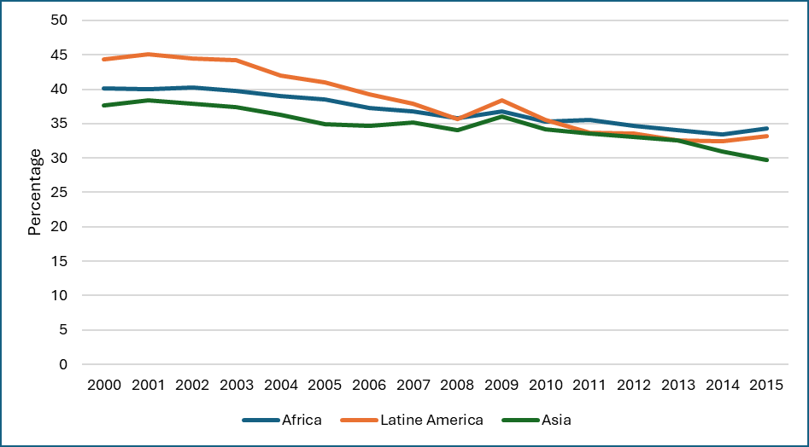
Source: The authors
2.2. Evolution of ICTs infrastructure indicators
Figure 2 shows strong growth in internet usage across all developing countries. However, Latin America and Caribbean countries are the most advanced with an average of 76% users in 2021 compared to 4% in 2000, an exponential increase of 1800% in 21 years. East Asia and the Pacific also recorded a significant increase in almost the same proportions. South Asia (42%) and Sub-Saharan Africa (36%) are the regions where internet penetration remains below the global average of 62% in 2021.
Figure 2 : Evolution of individuals using internet in some developing regions
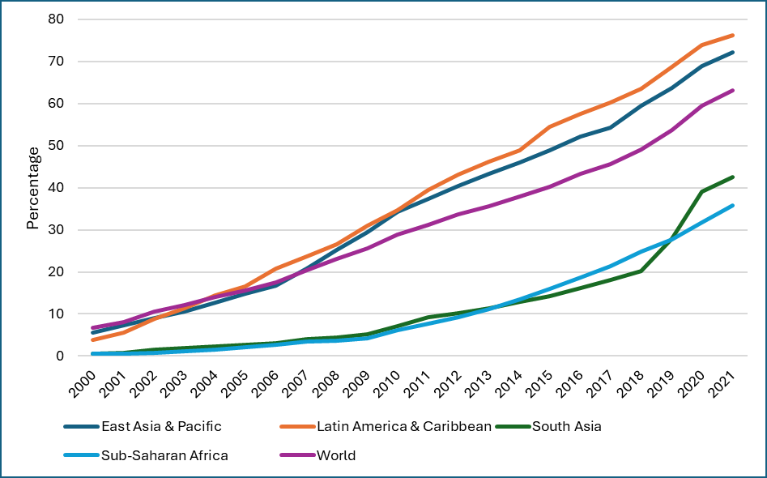
Source: The authors
Figure 3 shows the other ICT indicator also shows strong growth across all developing regions. This time, East Asia and the Pacific recorded the strongest increase since 2016, followed by Latin America, which is at the world average of 108 mobile cellular subscriptions per 100 people. South Asia is the region with the lowest mobile phone penetration.
Figure 3: Evolution of mobile cellular subscriptions in some developing regions
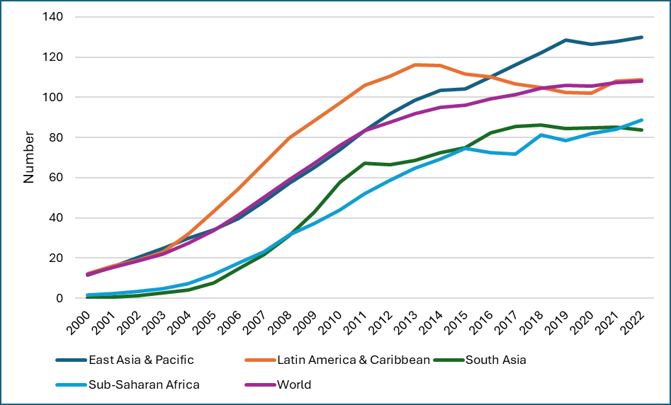
Source: The authors
3.Literature review
Informality remains a real problem for developing countries because it occupies on average more than 50% of the activity in these three regions of the world, thus requiring a comprehensive policy in terms of taxation, basic infrastructure, development of the financial sector, or even human capital, aimed at structuring informal activities.
The theoretical foundation of the informal economy dates back to the early 1900s, notably in 1920 with the Chicago School. Indeed, while the categories of informal, underground, or clandestine economy are relatively recent, the practices to which they refer have been known for a long time; nineteenth-century scientific and fictional literature was populated by "dangerous classes" engaging in activities that were condemned by law and morality (Cortado, 2014). Subsequently, the debate on the causes of underdevelopment in the 1950s brought the issues of marginality and the informal economy back to the table. It was later in the 1970s that the British anthropologist Keith Hart brought the concept of the informal economy to economics, challenging the idea that the "sub-proletariat" of the Third World was composed of unemployed or underemployed people, showing that this sub-proletariat spent a lot of its time and energy in activities that escaped the eye of the administration, hence the expression "informal income opportunity" to designate these activities (Cortado, 2014). Therefore, the informal economy is anchored in the economic literature through three approaches. The neoclassical approach according to which the growth of the informal economy is justified by the rationality of agents, the macroeconometric approach which attempts to estimate the size of the informal economy in terms of hidden added value as a percentage of GDP (Ndoya et al. 2023; Cagan, 1958; Tanzi, 1999), and finally the dualist, structuralist, legalist, voluntarist, free rider and bi-sectoral schools, which explain the growth of the informal sector by the growth rate of demand for employment (Ndoya, et al. 2023; De Soto, 1989; Moser, 1978; Tokman, 1978). The relationship between ICT and the informal economy is more recent and is rooted in the work of Stamp (1990), for whom ICTs contribute to the modernization of informal activities.
Empirically, few studies have assessed the effect of ICTs on informality and the results are not consensual. Garcia-Murillo and Velez-Ospina (2017) find that mobile phone penetration decreases transaction costs for informal firms and therefore increases their growth. Conversely, Remeikiene et al. (2022) analyzed the short- and long-term effect of ICTs on the informal economy and found that technologies reduce the informal economy, regardless of the period. Ajide and Dada (2022) found a bidirectional link between ICT and the informal economy. They suggest that better institutional quality is related to a reduction in the size of the informal economy (Loayza and Rigolini, 2011; Saunoris and Sajny, 2017; Berdiev and Saunoris, 2018). Fundamentally, institutional quality affects the costs and benefits of operating in the formal economy relative to the informal economy (De Soto, 2000; Perry and Maloney, 2007). Kartiasih et al (2023), assessed how ICT modulates the effect of informal sector on income inequality for Indonésia districts and cities. They used Generalized Method of Moments (GMM) as empirical strategy. the study shows that ICT measures directly exacerbate income inequality, otherwise mobile cellular penetration directly reduces it. Enhancing ICT beyond certain thresholds is necessary for ICT to modulate informal sector to reduce income inequality. The corresponding ICT thresholds for the reduction of income inequality is 32.78 mobile cellular penetration per 100 people. Ndoya et al. (2023), assessed the effects of ICTs on the informal economy in Africa. They found that the use of ICTs specially mobile phone and internet decreases the spread of the informal economy in Africa, and that informal economy is mediated by financial development, human capital and control of corruption.
Sodokin et al. (2023), explored the impact of e-commerce on company productivity by considering both formal and informal sectors in Togo. Applying endogenous switching regression and smoothed instrumental variable quantile regression, the study demonstrated that online businesses significantly increase productivity, particularly in firms within the informal sector. Maiti and Khari (2023), analyze the effects of digitalization on the size of informality in 148 countries for the period 1990-2017. They built a model with heterogeneous labour markets where the productive firms meet the tax burden to produce in the formal sector and the rest manages to survive in the informal sector by incurring extra-legal cost to avoid tax burden. They found that the digitalization increases the chances of being caught the informal transactions. Kotzinos et al. (2023), examined the effects of ICT penetration and the shadow economy on sovereign credit ratings and the cost of debt on a dataset of 65 countries from 2001 to 2016. They showed that policies facilitating the penetration and use of ICT and aiming to curb the shadow economy may exert an asymmetric impact on sovereign ratings and the cost of debt depending on their present magnitudes, not only independently but also in interaction.
Shahnazi et al. (2024), investigated the indirect effects of ICT on CO2 emissions through the informal sector in 24 high-income countries and 30 upper-middle and lower-middle income countries from 1995-2019. Using a threshold panel model, the findings indicated that in high income countries, both ICT and the informal sector contribute to reducing CO2 emissions. In countries with upper-middle and lower-upper-middle incomes, ICT reduces CO2 emissions, but the informal sector increases them. ICT has two thresholds, 0.976 and 61.57, in these countries. As ICT surpasses each threshold, the incremental effect of the informal sector on CO2 emissions declines. Ebrahim and van den Berg (2024), investigated the factors that influence the barriers to adopting digital technologies in South Africa’s informal economy. They used a qualitative approach on data collected from 14 informal business owners in Cape Town. They found that cash preference, load-shedding, crime and digital incompetency obstructing technology adoption. Despite these hurdles, the potential benefits of digital technology for informal businesses were underscored.
Bharwani (2024), investigated how digitalizing can help to capture unrecorded transactions and integrate them into the formal economy to boost Indonesia's GDP. Using a mixed-methods approach, the research combines quantitative analysis with qualitative insights from roadside business owners, financial experts, and policymakers. The results show that digitization of informal roadside businesses is indeed beneficial to both the economy and to the vendors themselves by providing them with access to financial systems they could use to distribute their finances better. Marire and Iqbal (2024), examined the effect of the infrastructure development index, the size of the informal economy, and the level of economic development on gender inequality. They used the panel autoregressive distributed lag method and showed that the infrastructure development index, its sub-indices, GDP per capita, and the size of the informal sector are crucial dynamics that governments need to consider.

4.Methodology and data
We know according to Stamp (1990), that ICTs infrastructure contribute to the modernization of informal activities. To assess the effects of ICTs infrastructure on the informal economy in our sample of developing countries, we follow the model of Ndoya et al. (2023), who assessed the effects of ICTs infrastructure on the informal economy in Africa.

4.1Model Specification

(1)
The dependent variable in the model is informal economy (Informeco) (Medina and Schneider, 2018). Many authors have used these data to analyze the informal economy (Ndoya et al. 2023; Njoya et al. 2023). ICTs infrastructure indicators are internet (the number of individuals using internet as percentage of the population) and mobile phone (mobile cellular subscriptions per 100 people). Previous studies used these indicators to measured ICTs (Epo and Nguenkwe, 2020; Ndoya et al. 2023). As control variables we have the GDP growth rate (Gdpg), rapid growth can lead to a decrease of the informal economy. A deep financial sector with high level of domestic credit (Cred) to private sector can contribute to a decrease of the informal economy. GOV is a set of two variables notably the control of corruption and the regulatory quality, that measure good governance in the view of Kauffman et al. (1996). High level of corruption is supposed to increase the informal economy, on the other hand, an improvement in the quality of regulatory quality supposed to reduce its place in the economy. HK stand for human capital measured by the life expectancy. Unempl stand for unemployment as a high level is supposed to expand the informal economy. , and are respectively the country individual effect, the time effect and the error term.
4.2 Estimation method
The nature of our sample, with the number of countries larger than the period of study, leads us to apply the generalized method of moments (GMM) in system to estimate our model. This method was introduced by Hansen (1982) and then generalised by Arellano and Bond (1991); Arellano and Bover (1995); and Roodman (2009). There are two main estimators, the difference and the system estimator.
This estimator controls for both individual and time specific effects and thus compensates for
possible endogeneity bias of the variables, given that there are one or more lagged variables in
the model. Hence, Arellano and Bond (1991) suggest that, in order to eliminate individual fixed effect, it is necessary to move from the reference equation to a first difference equation where the lagged level variables serve as instruments in the first difference equation. But the main limitation of this estimator is that the error term is by design correlated with the lagged
endogenous variable and the instruments are less relevant if the autoregressive process goes
beyond order 1. The system Generalized Moment Method estimator estimator fills in the limitation of the previous, following the study of Blundell and Bond (1998), who used lagged but differentiated variables as instruments. They show that the GMM estimator in difference can be severely biased, on the basis of Monte Carlo simulations,
when the number of individuals is finite and the period small; the number of moments is
relatively large compared to the individual dimension and the instruments are weak in the sense of Staiger and Stock (1997). Blundell, Bond and Windmeijer (2000) show that the system GMM estimator in improves very significantly the accuracy gains but also reduces
significantly the sampling bias.

4.3 Data
Data used in this paper come from many sources, informal economy data come from Medina and Schneider (2018), ICT and the remaining variables come from the World Bank World Development Indicators (WDI 2024). The study covers 50 countries from Africa, Latine America and Asia, on the period 2000 to 2015. The period is justified by the fact that informal economy data start in 1990 and end in 2015 (Medina and Schneider, 2018).

5.Empirical results
5.1Descriptive analysis
Table 1: Descriptive statistics of the variables
Variable | Observations | Mean | Standard deviation | Minimum | Maximum
Informal economy | 800 | 36.93806 | 9.37119 | 12.64 | 70.57
Mobile phone | 800 | 46.17645 | 42.18665 | 0 | 171.0096
Internet | 800 | 10.15892 | 14.091 | .0059021 | 76.62959
Corruption | 800 | -.5383892 | .6171381 | -1.57803 | 1.543591
Regulation quality | 800 | -.4782741 | .6383115 | -2.248597 | 1.536198
Credit | 800 | 24.68172 | 24.96162 | .0015445 | 127.2322
GDP growth | 800 | 4.518747 | 5.498551 | 50.33852 | 86.82675
Unemployment | 800 | 7.776589 | 6.138269 | .249 | 29.77
Interest rate | 800 | 7.599626 | 10.20588 | -60.78133 | 50.7601
Life expectancy | 800 | 61.36531 | 8.537089 | 42.914 | 79.746
Source: The authors
The table 1 shows the descriptive statistics of the variables. We can see that the mean of the informal economy is less than 10%, but that variable has a large dispersion with a minimum of 12.64% and a maximum of 70.57%. This is due to the differences that we have between the developing countries of Africa, Latine America and Asia. Indeed, the country with the deepest informal economy is Bolivia (70.57%) in 2001 and the country with the least deep informal economy is Chile (12.64%) in 2012. Regarding the use of internet, there are 14 users per 100 inhabitants in average, with a minimum of 0 and a maximum of 76 users, while for mobile phone use we have an average of 42 users per 100 inhabitants, with a minimum of 0 and a maximum of 171 users. The average growth rate is 5.5%.

Figure 4: Correlation between internet use and informal economy
Source: The authors
Figure 4 shows the relationship between internet use and the informal economy in developing countries in 2015. We see that there is a negative relationship between these two variables, which is consistent with theoretical predictions. Chile and Malaysia are the countries where internet use is most pronounced, with over 60% users, while African countries remain generally behind with less than 40% users, particularly 2% users in Burundi, which is last in the ranking.

Figure 5: Correlation between mobile cellular subscription and informal economy
Source: The authors
Figure 5 shows the relationship between mobile phone subscription and the informal economy in developing countries in 2015. We can see that there is also a negative relationship between these two variables, which is consistent with theoretical predictions. South Africa and Libya are the countries with the highest mobile phone penetration, with over 150 subscribers for 100 people, Malawi and Ethiopia are last in the ranking.

5.2Econometrics results
Table 2 presents the results of the estimation of the effects of ICTs on the informal economy in developing countries. The results are interesting because the probabilities of the post-estimation tests of validity of the Sargan instruments and that of absence of serial correlation at order 2 (AR 2) are higher than the threshold of 5%. The number of instruments is also significantly lower than the number of countries in all the estimations, which reinforces the quality of the estimations according to Roodman (2009).
From the Column (1) of the table 2 we focused on the results of the effects of mobile cellular subscription and corruption on the informal economy and from the column (2) we focused on those of internet use and corruption. We can see that The level of informality of the previous year has a positive and very significant effect on the informal economy of the current year at the 1% level, in all estimates. The penetration of mobile phone use is also considered a strong determinant of the informal economy because it is significant at the 1% level. Indeed, the number of cellular subscriptions is negatively and significantly correlated with the informal economy, showing that an improvement in the use of mobile phones contributes to reducing the share of the informal economy in GDP (column 1). This result is in line with those of Garcia-Murillo and Velez-Ospina (2017); Kartiasih et al (2023) and Ndoya et al. (2023).
We also see that the use of the internet is a determinant of the informal economy, but it is significant at the 10% level. The percentage of individuals using the internet is negatively and significantly correlated with the informal economy, indicating that an increase in the use of the internet also contributes to reducing the share of the informal economy in GDP (column 2). This result follows the one of Remeikiene et al. (2022).
Regarding the other explanatory variables, we see that human capital also explains the informal economy, the increase in life expectancy at birth leads to a decrease in the contribution of the informal economy to GDP, at the 5% threshold (column 1 and 2). The GDP growth rate, synonymous with the good health of the economy, is negatively correlated with the share of the informal economy at the 1% threshold (column 1 and 2). This reflects the fact that economic performance contributes to reducing the share of the informal economy (Marire and Iqbal, 2024). The interest rate is positively and significantly correlated with the informal economy at the 1% threshold, showing that an increase leads to an increase in the informal economy (column 1 and 2). Indeed, since the interest rate is the main determinant of investment, an increase can only discourage potential investors, especially young people, and push them towards low value-added activities such as informal activities, thus contributing to increasing their weight in economic activity. Finally, corruption and the unemployment rate are negatively linked to the informal economy, at the threshold of 1% and 10% respectively. The sign of these variables is, however, contrary to theoretical predictions, since they are expected to increase the share of the informal economy in economic activity.
From the Column (3) of the table 2 we focused on the results of the effects of mobile cellular subscription and regulatory quality on the informal economy and from the column (4) we focused on those of internet use and regulatory quality another proxy of the worldwide governance indicators (Kaufman et al. 1996). We can see that internet use and mobile phone use are still negatively and significantly related to informal economy at respectively 5% and 1% level. Regulatory quality is highly negatively and significantly related to informal economy at 1% level (column 3 and 4). This result is in line with the one of Ajide and Dada (2022), shows the importance that governance quality indicators can have in reducing informal activities. Indeed, the capacity of the government to effectively formulate and implement sound policies and regulations that permit and promote private sector development will help to reduce the share of informal economy. Finally, we see through columns 3 and 4 that economic growth rate, life expectancy at birth, the interest rate and the unemployment rate are significant with the same signs as in models 1 and 2.

Table 2: Estimation of the effects of ICTs infrastructure on the informal economy
 | (1) | (2) | (3) | (4)
 | Corrup mobile | Corrup internet | Regul internet | Regul mobile
VARIABLES
L.informal economy | 0.686*** | 0.811*** | 0.798*** | 0.706***
 | (0.0896) | (0.0541) | (0.0566) | (0.0847)
Mobile phone | -0.0139*** |  |  | -0.0109***
 | (0.00482) |  |  | (0.00413)
Corruption | -1.685*** | -1.007***
 | (0.452) | (0.278)
Credit to private sector | -0.00241 | 0.00248 | 0.00847 | 0.000308
 | (0.0116) | (0.0125) | (0.0156) | (0.0149)
GDP growth rate | -0.160*** | -0.166*** | -0.165*** | -0.162***
 | (0.0114) | (0.0114) | (0.0113) | (0.0112)
Life expectancy | -0.0261** | -0.0296** | -0.0327*** | -0.0314**
 | (0.0119) | (0.0119) | (0.0121) | (0.0123)
Interest rate | 0.0533*** | 0.0381*** | 0.0459*** | 0.0580***
 | (0.0121) | (0.00908) | (0.0101) | (0.0124)
Unemployment rate | -0.0668* | -0.0449 | -0.0584 | -0.0856**
 | (0.0365) | (0.0324) | (0.0366) | (0.0429)
Trade openness | 0.00594 | -0.000187 | -0.00462 | 0.000940
 | (0.0157) | (0.0156) | (0.0153) | (0.0151)
Internet |  | -0.0151* | -0.0178**
 |  | (0.00824) | (0.00842)
Regulatory quality |  |  | -0.968*** | -1.229***
 |  |  | (0.275) | (0.280)
Constant | 13.05*** | 8.775*** | 9.792*** | 13.24***
 | (3.009) | (2.103) | (2.265) | (3.084)
Observations | 749 | 749 | 749 | 749
Number of code | 50 | 50 | 50 | 50
AR (2) probability | 0.832 | 0.848 | 0.855 | 0.860
AR (1) probability | 0 | 0 | 0 | 0
Sargan prob | 0.199 | 0.272 | 0.402 | 0.374
Number of instruments | 23 | 23 | 23 | 23
Standard errors in parentheses
*** p<0.01, ** p<0.05, * p<0.1
Source: The authors

Conclusion
The objective of this paper was to analyze the effects of ICTs infrastructure on the informal economy in some developing countries of Africa, Latine America and Asia. We used generalized moment method and data from the World Bank and from Medina and Schneider to conduct the empirical analysis. Our descriptive analysis showed that on average the share of the informal economy in the GDP is higher in Africa (34%), compared to Latin America (32%) and Asia (30%). Preliminary statistical analysis showed a negative correlation between mobile phone use and the informal economy, as well as with internet use. Our econometrics results showed that internet use and mobile phone use are negatively and significantly related to the informal economy in the developing countries. GDP growth rate, human capital and regulatory quality are also negatively and significantly related to the informal economy, while interest rate is positively related to the informal economy. These results confirm theoretical predictions that ICTs, through their ability to facilitate transactions, can help reduce the size of the informal economy in developing countries and call on the authorities of these countries to invest more in their development in order to move to innovative technologies such as 5G and smartphones.

References

Bankole, F.O., K-M Osei-Bryson and I., Brown. (2015b). “The Impacts of Telecommunications Infrastructure and Institutional Quality on Trade Efficiency in Africa” Information Technology for Development 21(1), 29-43.

Bharwani, R. (2024), «The Impact of Digitalization on Informal Roadside Businesses in Indonesia and its Contribution to GDP”, The Lens Journal, Vol 2, Issue 3, DOI: 10.5281/zenodo.13685689.

Bhattacharyay, B.N. (2009) “Infrastructure Development for ASEAN Economic Integration” ADBI Working Paper No.138, Tokyo: Asian Development Bank Institute.

Blades, D., Ferreira, F.H. G., and Maria Ana Lugo, A.L. (2011), « The informal economy in developing countries: an introduction », Review of Income and Wealth, Series 57, Special Issue.

Cortado, T. (2014), « L'économie informelle vue par les anthropologues, regards croisés sur l’économie, N014, Pages 194 à 208.
Ebrahim, A.Q., and van den Berg, C.L. (2024), «The barriers to technology adoption among businesses in the informal economy in Cape Town”, South African Journal of Information Management, ISSN: (Online) 1560-683X, (Print) 2078-1865.
Epo, B.N., and Nguenkwe, R.B. (2020), “Information and Communication Technology and Intra-Regional Trade in the Economic Community of West African States: Ambivalent or Complementary?'', Economics Bulletin, Volume 40, Issue 2, pages 1397-1412.
Kaufmann, D., Kraay, A., and Mastruzzi, M. (1996), “The Worldwide Governance Indicators Methodology and Analytical Issues”, Policy Research Working Paper 5430, The World Bank Development Research Group Macroeconomics and Growth Team.
Kartiasih, F., Nachrowi, D,N., Wisana,D,G,K., and Handayani, D. (2023), « Towards the quest to reduce income inequality in Indonesia: Is there a synergy between ICT and the informal sector? », Cogent Economics & Finance, 11:2, 2241771, DOI: 10.1080/23322039.2023.2241771.

Kotzinos, A., Canellidis, V., and Dimitrios Psychoyios, D. (2023), « Informal Sector, ICT Dynamics, and the Sovereign Cost of Debt: A Machine Learning Approach”.
Maiti, D., and Khari, B. (2023), “Digitalization, Governance and the Informal Sector”, Institute of Developing Economies, Discussion paper No. 898.
Marire, J., and Iqbal, A.B. (2024), “Infrastructure development, informal economy, and gender inequality in Sub-Saharan Africa”, Journal of Infrastructure, Policy and Development, 8(6), 3413.
Medina, L and Schneider, F (2018), “Shadow Economies Around the World: What Did We Learn Over the Last 20 Years?, IMF Working Paper /18/17.
Nath, K.H. and L. Liu. (2017) “Information and Communications Technology (ICT) and Services
Trade” Information Economics and Policy 41, 81–87.
Ndoya, H., Okere, D., and Belomo, M.L., and Atangana, M. (2023), “Does ICTs decrease the spread of informal economy in Africa?”, Telecommunications Policy, Volume 47, Issue 2, 102485.
Njoya, L., Ngouhouo, I., Ngounou, B.A., Njoupouognigni, M., Nguena, C.L. (2023), “Informality and Inclusive Growth: What Lessons in the Literature from the African Experience?”, Environmental Modeling & Assessment, https://doi.org/10.1007/s10666-023-09934-w.
Shahnazi, R., Jamshidi, N., and Shafiei, M. (2024), “Threshold Effect of ICT in the Impact of the Informal Economy on CO2 Emissions” Clean Technologies and Environmental, DOI: https://doi.org/10.21203/rs.3.rs-3202721/v1.
Sodokin, K., Djafon, K.J., Couchoro, M.K, Kounetsron, Y.M., and Ega Agbodji, A.E. (2023), “Technological change, the productivity of formal and informal businesses, and the impact on labor market”, Cogent Economics & Finance, 11:2, 2268790.

